Service Upgrades for Electrification Retrofits Study Draft Report
March 21, 2022

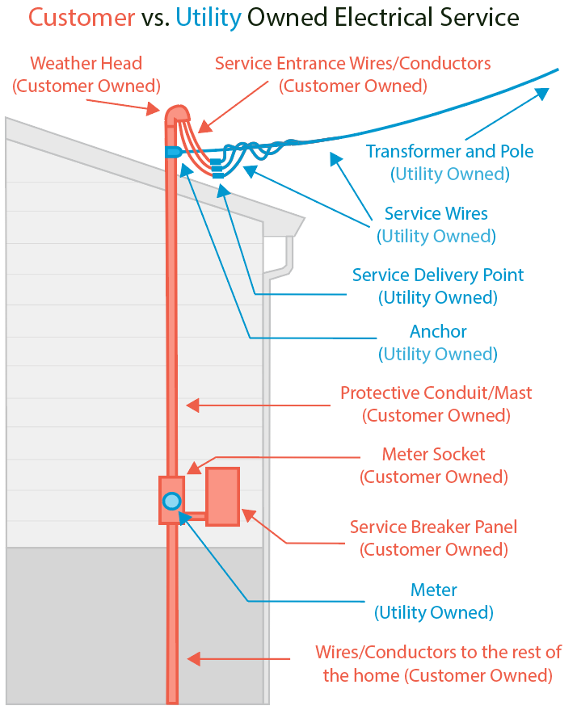
Courtesy of Emily Higbee, Redwood Energy Research Director
The above image displays ownership of basic electrical service equipment that will be assessed by an electrification retrofit contractor to complete an overhead Service Upgrade. All the components depicted in the diagram are within the scope of an electrical Service Upgrade discussed in the report except for new wires to the rest of the home.

CALMAC STUDY ID: PG&E0467.01

Contributors

NV5 Inc.
Shoshana Pena, Director of Program Services
Collin Smith, Program Manager
Greg Butsko, Vice President of Distribution Services
Rick Gardner, Director of Distribution Services

Redwood Energy
Sean Armstrong, Principal
Emily Higbee, Research Director
Dylan Anderson, Senior Staff Researcher
Rebecca Hueckel, Senior Staff Researcher

PROJECT SPONSORS
Pacific Gas and Electric Company
San Diego Gas and Electric Company

Table of Contents
Executive Summary 4
Key Findings 5
Key Recommendations 6
1.0 Introduction 9
1.1 Objectives 9
1.2 Methodology 11
1.3 Background 14
2.0 Study Findings 17
2.1 Map out existing process 17
2.2 Understand costs incurred by all parties 31
3.0 Conclusions and Recommendations 35
3.1 Conclusions 35
3.2 Recommendations 39
4.0 Appendix 46
4.1 Customer Online Surveys 46
4.2 Contractor Interviews 48
4.3 Literature Review 51
4.4 Research plan and Interview Study Guides 59

Executive Summary

The Service Upgrades for Electrification Retrofits Study (Study) conducted on behalf of Pacific Gas and Electric Company (“PG&E” or “Utility”) and San Diego Gas and Electric (“SDG&E” or “Utility”) began in June 2021 with the goals to examine both the processes and costs required to upgrade electrical service capacity when completing residential electrification retrofits, and make recommendations to PG&E and SDG&E (collectively “Utilities”) and future program implementers on process improvements for integrating service upgrades into electrification projects. Electrical service upgrades (Service Upgrades) are typically defined as an upgrade in amperage capacity from the pole to the residential meter. For the purposes of this Study, Service Upgrades may include work from the pole to the panel but excludes anything on the home side of the panel such as new wiring (Figure 1).
Figure 1 - Service Upgrades
Pole to Panel
123456
KILOWATTHOURS

As the California residential building market is rapidly shifting towards electrification and reductions in natural gas construction and appliances, the Utilities created this Study to explore potential support opportunities for customers who may be impacted by Service Upgrades due to electrification retrofits.

This Study contains findings and recommendations to address challenges for integrating Service Upgrades into electrification projects. These recommendations include ways that Utilities can improve the Service Upgrade process, recommendations for potential program implementers on incorporating Service Upgrades into electrification programs, and identifies future research needs for the Utilities and program implementers.

The Study participants were homeowners and contractors in the PG&E and SDG&E service territories that completed a Service Upgrade in 2020 and Q1 2021. They were interviewed and completed online surveys from August 2021 through December 2021. Subject matter experts (SMEs) from PG&E and SDG&E, local jurisdictions, and California Public Utility Commission (CPUC) were interviewed.
- A total of 34 homeowners from PG&E and SDG&E service territories responded to the survey out of the 136 homeowners contacted. Of the 136 total homeowners contacted, 58 homeowner contacts were provided in the PG&E data request response and 78 were provided in the SDG&E data request response,
- 23 contractors completed interviews out of the 141 residential electrical contractor companies contacted.
- A total of 12 Utility, CPUC, and building department staff were surveyed or interviewed out of the 29 contacted. A breakdown of the 12 completed interviews is:
  - Three Building Department staff (two from PG&E service territory and one from SDG&E service territory)
  - Three CPUC staff members
  - Six Utility SMEs (three from PG&E and three from SDG&E)

Key Findings
The key findings from the Study are summarized below:
Service Upgrade Triggers
- When a Service Upgrade is required, it is most often a direct result of an electrical panel upgrade triggered by insufficient service capacity required to meet a customer’s increasing electrical load. Most customers and contractors are unaware of available options to mitigate the need for a panel upgrade that would trigger a Service Upgrade.
Service Upgrade Process
- Some customers reported that the overall Service Upgrade process is confusing, and it took longer than expected, often exceeding six to nine months. Some customers stated there was a lengthy waiting period between the initial application and initial project estimate from the Utility.
- Some Utility staff Subject Matter Experts (SMEs) reported a perception that a lot of time is spent communicating with customers as opposed to reviewing and processing Service Upgrade applications. This may be due to a variety of issues including time spent addressing customer response accuracy, a lack of automated updates to customers through SAP, time needed to fully address customer questions and concerns, and time spent educating customers on the process.
- Applications with missing or erroneous information may be voided by one Utility after 30 days of no applicant update, requiring a full application restart despite any work previously reviewed.
- Some Utility staff and contractors reported they would benefit from customers and contractors having access to increased educational information on the process, requirements, and costs associated with Service Upgrades. There are manuals and guidance docs available such as Utility’s Electric and Gas Service Requirements, but contractors were unaware of them.
- SDG&E SMEs reported that it is common for solar photovoltaic sales teams to submit Service Upgrade applications for a batch of customers in a neighborhood that they canvass prior to signing an agreement. This results in Utility staff working on applications that typically never become projects. PG&E did not report this issue which may be due to the requirement to submit load calculations and onsite photos as part of the application.
Service Upgrade Costs
- Customers are typically unaware of the full cost of a Service Upgrade. The contractor’s bids are typically an all-inclusive cost that includes all equipment, material, labor, and panel upgrade costs with minimal to no cost breakdown. The bids may include Utility-side costs in a single bundled invoice amount. Customers are unaware of the Rule 16 allowance covered by the Utility.
- Contractors reported that it is uncommon for the Rule 16 allowance amount to cover the full cost of the customer’s Service Upgrade. PG&E reported in a data request response that typically any Service Upgrade job that is more than just a line replacement will exceed the $2,154 allowance.
- Customer costs can be organized into three categories, (1) the Service Upgrade paid to the Utility, (2) the customer-owned electrical panel upgrade paid to the contractor such as an electrician or solar company, and (3) other customer costs such as trenching that are often paid to a separate contractor. Each of these categories includes three items: labor, materials, and permit costs. The total cost for all three categories was reported to range between approximately $2,000 to $30,000.
  - Service Upgrade. Rules 15 and 16 govern the allowance for Service Upgrades totaling $2,154 for PG&E and $3,241 for SDG&E. Utility contractors reported customers may pay between $300 and $16,000 or more to the Utility for costs that exceed the allowance. The factors that determine costs are meter and pole location, construction requirements, trenching requirements, and distance to the distribution infrastructure.
  - Customer-owned electrical panel upgrade. Customers are always fully responsible for an electrical panel with costs ranging between $2,000 and $4,500 with an average cost of $2,780. This cost does not include additional customer costs incurred if they are responsible for any portion of Utility infrastructure, or other costs such as trenching, excessive run distances, or higher labor prices in affluent areas.
  - Other costs. Other Service Upgrade related costs the customer may typically be responsible for, but not limited to, include trenching, permits, easement costs, conduit replacements, and potential pole and transformer partial cost replacements. Permit costs ranged between $130 to $170, depending on the jurisdiction. PG&E reported the cost of a new transformer is between $6,000 to $8,000. If there are three or more customers on the transformer, the transformer and pole upgrade cost is covered by the Utility. But if there are less than three customers on the transformer, the customers are required to cover a portion of the cost of the transformer and pole upgrade. If there is only one customer on the transformer, the customer requesting the upgrade is required to cover the costs of the transformer upgrade and pole upgrade, if needed. Contractors reported these additional costs range between $2,850 to $30,000 or more.

Key Recommendations
Based on the key findings, the Study team recommends that the Utilities consider the following recommendations:
Service Upgrade Triggers
Service Upgrades are triggered by electrical panel upgrades that are often avoidable due to a lack of contractor education and incentives.
- Leverage Workforce, Education, & Training (WE&T) programs to integrate education on the options to mitigate the need for a panel upgrade. Electricians drive the decision to upgrade in the face of the cost. Increase contractor awareness of the existing Utility Electric and Gas Requirements Manual.
- Incentives to avoid panel upgrade. Consider nonfinancial and financial program incentives that encourage mitigating the need for upgrading a customer’s electrical panel that will trigger a Service Upgrade.
- Require inspectors to assess the need for a panel upgrade and provide a report to the customer. In addition to contractor education, Utility and Building Department inspectors should be trained to assess the need for a panel upgrade and provide the customer with a panel report and a leave-behind pamphlet explaining options to avoid the need for a panel upgrade and potential cost savings. This recommendation also supports decreasing the Service Upgrade cost category below.
Service Upgrade Process
To improve the Service Upgrade process, Utilities must improve the timeline, improve communication with the customer, and right-size resources to meet the customer’s increasing demands.
- Expand existing software platform for Service Upgrades to reduce customer confusion, set timeline expectations, and reduce time spent by Utility staff communicating with customers. Improve upon and expand the Utilities’ existing customer-facing software platform to enhance the customer experience and “at will” information exchange. The system should focus on the timeline and cost expectations, frequently asked questions, and provide customers and contractors with automated status updates with important notifications to understand steps completed and upcoming requirements. The system must identify and track issues with applications reported by Utility SMEs during any stage of the application to reduce the administrative burden on Utility staff. It must allow more detailed customer project tracking than currently available.
- Develop a system for Utility staff to visualize capacity constraint. Utilities should consider tracking the location of Service Upgrades on a neighborhood or multi-group level and flag those areas as potentially requiring more extensive distribution level upgrades as electrification adoption increases.
- Leverage existing resources. Consider leveraging internal Utility continuous process improvement resources that will assess and report on the Service Upgrade timeline, process automation and system upgrades.
- Develop and share Utility-specific best practices. There are differences between the PG&E and SDG&E Service Upgrade process. The Utilities will benefit from sharing best practices and lessons learned for processes and customer application intake, requirements, and scheduling.
Service Upgrade Costs
The customer pays a contractor for the home upgrades but, in addition, must pay the Utility up to $30,000 or more to upgrade the Utility’s infrastructure from the customer’s meter to the pole. These are recommendations to decrease the cost impact.
- Leverage industry best practices to conduct education and training for contractors and inspectors on the options to mitigate the need for a Service Upgrade, Service Upgrade processes, and all costs associated with a panel upgrade and Service Upgrade.
- Decreased cost. Increase the Rule 16 allowances to reduce the cost burden on the customer. Identify other incentive mechanisms to offer incentives to customers to further reduce the cost burden of the Service Upgrade, particularly during electrification retrofits. These incentives could be included in parallel to statewide decarbonization, demand response, energy efficiency third-party, EV charging, or self-generation incentive programs.

Introduction
The Study team conducted a variety of data collection and literature review activities focused on assessing the processes and costs required for residential Service Upgrades. The simplified objectives of the Study are listed below, the full Study objectives are listed out in Section 1.1.

- Map out existing process for completing Service Upgrades in residential retrofits.
- Understand the costs incurred by all parties when upgrading electric service to residential sites.
- Make recommendations to the Utilities and future program implementers to address the challenges to integrating Service Upgrades into electrification projects.

Beginning in August 2021, homeowners, contractors, building department staff, Utility staff and CPUC staff were contacted to participate in either an online survey or in-depth interview. A literature review of the Utility’s existing documentation and online data available on cost was conducted to supplement the Study team’s understanding of Service Upgrades, in parallel with conducting interviews, and supported the Study findings. In addition, the review of the Utility’s Rules informed the interview and survey questions for homeowners, contractors, building departments and Utility staff.

Due to the increasing electrification of the residential sector, the goal of this Study is to provide the Utilities with actionable recommendations and strategies to support California’s decarbonization initiatives. The Study objectives and associated activities focused on uncovering ways the Utilities and future program implementers can facilitate an improved Service Upgrade process for homeowners and contractors.

Objectives
The objectives of the Study were to map out the existing process for Service Upgrades, understand the costs incurred by all parties and make recommendations for the Utilities and future program implementers.

OBJECTIVE 1: MAP OUT EXISTING PROCESSES FOR COMPLETING ELECTRICAL SERVICE UPGRADES IN RESIDENTIAL RETROFITS
Activity 1: Identify common scenarios when Service Upgrades are required to complete electrification upgrades in residential retrofits and develop several representative examples.
- What set of information is required to determine whether a Service Upgrade is required?
- What alternatives are considered to alleviate the need for these upgrades?
- What set of conditions typically trigger the need for Service Upgrades? May include:
  - Building characteristics, like type, vintage, etc.
  - Specific appliance installation or combination of domestic hot water, Heating Ventilation Air Conditioning (HVAC), cooktops, dryers, electric vehicles, etc.
  - Interaction with solar and battery storage systems
- How is the California Title 24 – Administrative (Part 1), Energy (Part 6), Electric (Part 3) and Fire (Part 9) Codes addressed in the common requirements for a Service Upgrade?
Activity 2: Identify current processes in place to complete the Service Upgrades and develop process flow charts.
- What are the various steps required to complete a Service Upgrade, from conceptualization through implementation? Include details on:
  - Electrical upgrades required for service panels, electric panels, and branch circuits
  - Infrastructure requirements if gas end uses are removed from the building, such as capping gas lines
  - Required expertise
  - Permitting requirements
- Who is responsible for the execution of each component of the Service Upgrade process such as the Utility, electrician, homeowner, etc.?
- What is the typical timeframe required to execute each step?
- What are potential barriers that exist at each step?
- Under which scenarios do customers abandon electrification retrofits due to Service Upgrade challenges?

OBJECTIVE 2: UNDERSTAND THE COSTS INCURRED BY ALL PARTIES WHEN UPGRADING ELECTRICAL SERVICE TO RESIDENTIAL SITES
Activity 1: Identify typical costs associated with increasing electrical capacity for residential electrification retrofit projects and the parties responsible for these costs.
- What are the costs or cost ranges associated with electrical capacity upgrades, which may include, but not limited to:
  - Professional service fees from electrical engineers, electricians, contractors, plumbers, etc.
  - Branch circuit costs
  - Electric panel costs
  - Utility fees, e.g., Service Upgrades, gas service termination
  - Costs associated with capping or removing existing gas plumbing
  - Permitting and inspection costs
- Who is responsible for the cost of each component of the Service Upgrade process such as the Utility, homeowner, etc.?
Activity 2: Identify and explain factors that may impact these costs.
- What factors may cause these costs to be higher or lower, including:
  - Building location
  - Building characteristics such as type, vintage, etc.
  - Physical constraints such as distance to line, etc.
- Are these costs expected to change over time? If yes, why?

OBJECTIVE 3: MAKE RECOMMENDATIONS TO THE UTILITIES AND FUTURE PROGRAM IMPLEMENTERS TO ADDRESS THE CHALLENGES TO INTEGRATING SERVICE UPGRADES INTO ELECTRIFICATION PROJECTS
Activity 1: Identify ways that Utilities can improve Service Upgrade processes.
- What are the biggest hurdles to Service Upgrades, and how can Utilities help customers overcome them?
- What strategies would improve the process for successful Service Upgrades? Recommended strategies may include (but are not limited to) those listed in Strategies and Approaches for Building Decarbonization (Building Decarbonization Coalition 2019).
  - Ensuring Affordability and Equity
  - Workforce Training and Development
  - Developing Markets: Upstream and Midstream Programs
  - Deploying Rate Design with Demand Management
  - Harnessing Consumer Investment: Downstream Programs
  - Financing Building Electrification
  - Local Government Initiatives
Activity 2: Develop recommendations to potential program implementers on incorporating Service Upgrades into electrification programs.
- What pitfalls associated with Service Upgrades should implementers look out for when designing electrification programs?
- What other considerations should implementers be aware of?
Activity 3: Identify future research needs
- What support can the California Public Utilities Commission (CPUC) provide to streamline electrical service upgrades? How can the CPUC value the avoided costs of electrical service upgrades when low-amp alternative appliances are pursued?
- What is the current customer demand for electrification retrofits?

Methodology
A high-level approach to the methods and strategies for data collection and analysis are listed below, including in Table 1 which addresses the three Study objectives. Refer to Section 4.4 for the complete research plan and interview study guides.

- Online Surveys: These were conducted with homeowners who recently completed Service Upgrades with their Utility. Additionally, a follow-up phone call was attempted with homeowners who opted-in to a phone call to discuss the responses.

- In-Depth Interviews: Telephone interviews were conducted with contractors, Utility SMEs and building department staff who were involved with Service Upgrades. The building department staff interviewed worked on building permits for residential Service Upgrades. In addition, CPUC staffers were interviewed to gain additional knowledge on how the Utility’s tariff Rules are developed and reviewed for rate case approvals.

- Literature Review: The Study team reviewed existing Service Upgrade data and studies to inform the interview and survey questions and analysis for recommendations.

Table 1: Research Methods, Sample Size, Target Audience, and Incentives
Research Method | Study Targets and Actuals
 | target | Actual Completed | Target Audience | Incentives
Online Surveys | 50 | 34*  PG&E: 15  SDG&E: 19 | Homeowners | $50
In-depth Interviews | 40 | 23**  PG&E: 12  SDG&E: 11 | Contractors/Trade Professionals | $150
 | 10 | 3  PG&E: 2  SDG&E: 1 | Building Department Staff | None
 |  | 3 | CPUC Commissioners
 |  | 6  PG&E: 3  SDG&E: 3 | Utility SMEs
* 11 of the 34 homeowners provided partial responses to the survey and/ or did not fully complete it.
**Three of the 23 contractors provided partial responses to the interview questions and/or did not fully complete it.

Recruitment Plan
The Study team utilized several methods to recruit participants in the surveys and interviews.

Homeowner Recruitment: The Study team submitted a data request for a list of customers from both PG&E and SDG&E who completed a Service Upgrade within the last 24-months from the respective Utility. The Utilities sent a notification email to the customers informing them that a survey was being conducted. Then the Study team followed up with regular reminder emails.

Contractor Recruitment: For the contractor recruitment, recruiting electricians to participate in the study was prioritized over other building trades because they are the most involved in the Service Upgrade process. Most of the interviews came from calling contractors and trade professionals identified by the Study team as good candidates for interviews. The Study team developed a list of contractors from various sources: (1) Energy Connection’s “Find a Contractor,” an online tool for homeowners to find contractors that are knowledgeable in high performance buildings and building electrification, (2) top-rated trade professionals in major cities, and (3) the Decarbonization Working Group listserv of electrification focused professionals in California. In addition, the Study team leveraged existing contractor relationships to obtain interviews and bid information. The PG&E team also sent an outreach email to a list of verified contractors requesting their assistance in Study participation after an initial round of contractor outreach resulted in lower participation than expected.

Utility Subject Matter Experts and CPUC Staff: This group was reached by utilizing the Study team’s professional contacts to find the most applicable interviewees.

Building Department Recruitment: The Study team called permit offices of major cities to interview building department representatives.

Cost Analysis
Cost data was collected from customers and contractors. Because customers are the entity that incur the costs, directly or indirectly, valuable cost data came from the customers’ input. However, as customers are less able to report background costs such as traffic permits, and they are less likely to be aware of the effects of incentives under Rule 16, the collected data includes only what costs the customer incurs. For that reason, cost data was collected from electrical contractors who performed the homeowner’s service panel replacement, and Utility contractors who perform Utility work on the Service Upgrade. Cost implications can be better understood with input from all three of these market actors.
For data collected on Service Upgrade triggers, processes, and timelines, the primary mode of analysis was qualitative —gathering information including the pain points and successes of customers, contractors, and Utility staff allows the Study team to refine recommendations that benefit all parties and improve the process for the customer. Quantitative analysis, where required, took the form of taking the average, range, or comparing the relative quantities of various responses to determine the major factors impacting Service Upgrades and costs.

Limitations
The Study’s findings are from a relatively small pool of Utility customers and contractors. The Study is primarily qualitative and more robust quantitative analysis is needed to validate the findings in this Study, assuming the Utility data system and confidentiality issues can be resolved.

Response Rate. The Study team requested 100 verified customers from each Utility. There was a lower-than-expected response rate so the request should have been doubled to increase the sample size.

Cost Detail. The Study team leveraged industry relationships to gather cost details available. There are two cost components: (1) Project costs customers pay to contractors and (2) Service Upgrade costs the customer pays to the Utility. There were a few full-service electrification contractors that shared detailed bid data. Three Utility-side contractors shared high-level Service Upgrade cost information during the interview process.

Incentive Amount. The contractor incentive amount of $150 may have been insufficient for the requested amount of time required to participate in the Study. Although contractors were compensated for their time, some contractors reported that time as a potential “lost job” which could have had the opportunity for more revenue. Increasing the contractor incentive would have increased participation.

Background
The relevant Tariffs and protocols of the Utilities regarding Service Upgrades follow a predetermined set of requirements and regulations. This includes Rule 2: Description of Service, Rule 15: Distribution Line Extensions, Rule 16: Service Extensions and the Utility Electric Design Manual, and Rule 20: Replacement of Overhead with Underground Electric Facilities. The Rules or Tariffs are developed by the California Public Utilities Commission and are followed by the Investor-Owned Utilities in California.

Tariff Rules
Rules 15 and 16 are the main rules that govern the requirements for a Service Upgrade. In Rule 15 for distribution line extensions, it outlines: general requirements, installation responsibilities of the customer (Applicant) and the Utility, distribution line allowances, advances by the Applicant, refundable and nonrefundable payments, Applicant design and installation options, and special conditions. In Rule 16 for service extensions, it outlines: general requirements, metering facilities, service extensions requirements, responsibilities for service extensions by the Applicant and the Utility, allowances and payments by Applicant, and exceptional cases.

Distribution Line and Service Extension Allowance
For a residential Service Upgrade, there is a cost allowance for the upgrade, which seeks to establish an “average” cost paid by the Utility for service extension costs. Each Utility estimates the average project costs that are typically covered by the allowance during rate filings, and results in the amount that is covered by the Utility. However, if the individual Applicant project is estimated to cost more than the allowance, the Applicant is required to pay the difference before the project begins. As shown in Table 2, the allowance for PG&E is $2,154 and $3,241 for SDG&E. This allowance is first applied to the residential service, then what is left over is applied to the distribution line extension.

Table 2: Extension allowance and Cost of Service Factor for PG&E and SDG&E.
 | PG&E | SDG&E
Allowance* | $2,154 | $3,241
Cost of Service Factor** | 14.64% | 14.63%
* Allowances are set as the distribution line and service extension portion of the (Utility Net Revenue) divided by the (Cost of Service Factor). Defined in Rule 15 Section C.3
** The Cost of Service Factor includes depreciation, return, income taxes, property taxes, Operating and Maintenance (O&M), Administrative and General (A&G), Franchise Fees and Uncollectible Expenses (FF&U) and replacement of facilities for 60 years at no additional cost to customer. Defined in Rule 15 Section J for SDG&E and Rule 2 Section 1.3.b for PG&E

Utility and Customer Responsibilities
The most pertinent information for this Study outlined in Rule 16 describes the responsibilities of the Applicant and the Utility. This describes which party is responsible for costs of different parts of the Service Upgrade. The Utility is responsible for planning, designing, and engineering the service extension and/or distribution line extension, using their standards for materials, design, and construction. However, the Applicant may use the Applicant Design Option, where instead they can select competitive bidding and the service extension may be designed by a qualified contractor (the requirements for this design option are described in Rule 15 Section F). In addition, the Utility is responsible for the electric service, meter, and transformer — extending from the distribution line to the service delivery point.

The Applicant is responsible for providing a clear route on private property (or paying for one to be established) and excavation: all necessary trenching, back filling, and other digging required including permitting fees. In addition, the Applicant is responsible for furnishing, installing, owning, and maintaining all conduit and substructures and protective structures. Beyond the service delivery point, the Applicant is responsible for planning, design, installing, owning, maintaining, and operating the service facilities, except for the meter itself.

In addition, Rules 15 and 16 reference Rules 2 and 20. Rule 2 is the Description of Service and outlines the service voltages to be distributed to customers, voltage frequency control requirements, load limitations, and interferences with service, but as it relates to Service Upgrades – Section I on Special Facilities. If a Service Upgrade project is deemed above what is standard as a “Special Facility,” then the Applicant is responsible for additional costs above the standard for this project.

Rule 20 describes the requirements for the conversion of overhead to underground distribution lines. The Utility (at its expense) will underground their overhead electrical lines along public streets and roads, public lands, and private property when rights-of-ways have been obtained. As it pertains to residential retrofits, (if a jurisdiction decides it wants to underground their electric distributions and following the Utilities requirements) the Utility will pay for no more than 100 feet of each customer’s underground electrical service lateral and will pay up to $1,500 per service entrance (excluding permit fees). However, the governing body may limit these for a particular project.

Utility Electric and Gas Service Requirements
The Utility’s Electric and Gas Service Requirements document is a guide for contractors and project planners describing the technical and procedural requirements for completing a Service Upgrade. For example, Section 3: “Electric Service Underground” provides information to help applicants, their engineers and contractors select appropriate locations for an underground electric distribution system. Section 4: “Electric Service Overhead” provides instructions and minimum clearance requirements for overhead electrical service. This document references the Tariff Rules frequently and offers a more detailed manual on how to complete a Service Upgrade project, along with specific material requirements to be used for electric service facilities.

Study Findings
This section discusses the findings of the Study by first discussing the existing process including common scenarios and triggers for a Service Upgrade. This is followed by a discussion on the costs incurred by each party.

Map out existing process

Identify common scenarios when Service Upgrades are required to complete electrification upgrades in residential retrofits
The common scenarios when Service Upgrades are required to complete electrification upgrades in residential retrofits fall into two categories. Beyond these two categories, there are several other items that are common on Service Upgrades.

Category 1: Electric load requiring more service capacity

A home’s vintage. Homes built prior to 1965 are the most likely to have panel sizes below 100-amps. Customers completing electrification retrofits, installing an EV Charger and solar or other improvements that require more service capacity will require a panel upgrade that will trigger an unavoidable Service Upgrade.

A home’s size. A good indicator for the need for a home’s electrical panel upgrade is often the size of the home. A home electrical panel upgrade from 100-amps is only necessary in most of California for single-family homes that are over approximately 2,000 square feet. A brand new, appropriately sized gas-fired heating only system in homes over 2,000 square feet with no air conditioner (A/C) would result in an equivalent electric heat pump system when converting to an all-electric HVAC system --- which would likely exceed the remaining capacity of the existing panel circuits due to the fuel switch for heating. However, if central air conditioning is already present, a new electric heat pump is typically sized the same - requiring only the same circuit size as the original A/C installed, so the A/C circuits can generally be reused. Recent construction homes larger than 2,000 square feet typically already have 200-amp service, rather than 100-amp service, and a 200-amp service panel is the Title 24 code requirement as of 2019.

Electric load increases requiring more service capacity. This is the case with electrification retrofits such as solar, EV charging, new HVAC equipment, pool pumps, induction ranges, or heat pumps for water or space heating.

Multiple units and meters on a property. If a single-family home is subdivided into multiple units, it would be expected that the added appliances at the lot (new electric stoves, water heaters, clothes dryers, HVAC) would add to the overall potential “coincident” load at the site, and more service capacity would be required as per the electrical code requirements for service panels and feeders.

Accessory Dwelling Units (ADU), workshops, barns, and other additions to a home can trigger a Service Upgrade if the service wires are below the newly required capacity. An ADU may also have a separate meter if it has a separate address to the main house.

Type of Panel Upgrade. It is common for contractors to recommend replacing an existing electrical panel with a panel of a greater amperage. This will require the Utility to provide an increased service drop, which will increase the level of review to a new service of which a Service Upgrade is the sub-category. It is less common for customers to replace an electrical panel with a panel of the same amperage for fire safety reasons or improved functionality such as a smart panel. Smart panels include only those electrical panels that are able, via Wi-Fi, internet, algorithms, or other methods, to control energy loads at a given home on a basis of timing and usage, and that distribute power according to the circuits added to reduce power to loads that are not in use and to increase available power to loads that are able to be used. This is defined in this Study as a like-for-like panel upgrade (Like-For-Like Panel Upgrade). Like-For-Like Panel Upgrades require less Utility review because the size of the service drop and size of the panel does not change, and no upstream infrastructure will be impacted.

Category 2: Codes and Standards.

Historically, some homes had the Utility meter in garages or other publicly inaccessible space, and to be brought up to code, a cascade of electrical work including a possible Service Upgrade can be triggered by something as simple as a new circuit box being added. When a meter is inaccessible to the Utility, it must be moved to a publicly accessible location.

Other Common Factors

A customer’s service panel sizing determines the capacity of the needed electrical equipment on the pole or from the transformer, as well as the size of wires in the “service feeder,” which is the line connecting the utility to the customer. If the service feeder and transformer, are not rated for the capacity the customer requests, it must be upgraded in accordance with Utility rules, the “Green Book” requirements, and the electrical code requirements of the authority having jurisdiction (AHJ). On the customer side, the electrical panel Load Calculation process that is outlined by the 20197 California Electrical Code (CEC) Article 220.82(A), is the primary set of code requirements that determine the size of the customer’s electrical panel, which in turn determines the size of the required service feeder line from the Utility under Article 220.61. This was a consistent answer from our electrician respondents; “the result of the panel calculations tells me that I have to install a bigger panel, so I do, which means talking to the Utility about upgrading the service feeder.” The homeowner’s panel sizing is important to recognize because there are alternatives to panel upgrades that are almost always left unexplored, and they can help reduce the load on the panel which can help to avoid a panel upgrade.

Electrical upgrades required for service panels and branch circuits. The CEC Article 220 indicates the electrical sizing of the service panel that the customer owns determines the requirements under the Green Book for the meter size and the service feeder size. Appliances on various branch circuits of the panel determine the required capacity of the busbar and main breaker. This relationship creates a dynamic in which, potentially, a customer who wants to install just one new appliance triggers a stream of events that leads to that customer requesting a Service Upgrade from the Utility. There is an anticipated increase in Service Upgrade requests for customers who are completing electrification upgrades and retrofits, but there are methods available to help customers avoid a service panel upgrade and avoid needing a Service Upgrade request to the Utility. There is already an increase in Service Upgrade applications due to other factors, including Solar PV.
Infrastructure requirements if gas end uses are removed from the building. Utility staff and contractor respondents indicated that capping a gas line at the meter is a job that is often done for free, although there have been anecdotal reports of costs associated with removing the meter, the respondents in interviews and surveys did not indicate an occurrence of costs. Infrastructure requirements include shutting off the gas line to the meter, removing the meter, and capping the gas line from the transmission line in the street or elsewhere.

Required expertise. For Service Upgrades, a lineworker is required, as well as a general contractor or a C-10 electrical contractor license. In California, these skills can be obtained from several technical colleges, IBEW Union Locals, and other accredited training programs. For removing a gas line, a Utility certified gas contractor is required. This required expertise was considered by some Utility staff interviewed to be in short supply, especially in the areas of lineworkers and Utility-side electrical contractors.

Permitting requirements. For a Service Upgrade, an electrical permit is not the only requirement. The Utility contractor is responsible for obtaining a traffic control permit from most local authorities, and this can represent a considerable time step in some jurisdictions and in high traffic areas. The Utility contractor usually absorbs this cost, and indirectly passes it to the customer.

What set of conditions typically triggers the need for Service Upgrades?
When a Service Upgrade is required, it is most often a direct result of an electrical panel upgrade triggered by insufficient service capacity required to meet a customer’s potential increase in electrical load. The conditions that trigger an electrical panel upgrade are also triggers for the Service Upgrade as illustrated (Figure 2).
Figure 2 - Service Upgrade triggers

Most common triggers reported by Utilities data. The Utility’s Service Upgrade data request response indicated that the most common trigger for a Service Upgrade is a solar PV installation (43%), followed by Level 2 EV Chargers (12%). The two leading triggers accounts for 55% of all Service Upgrades. The remaining Service Upgrades are noted as wiring upgrades which is assumed to be associated with home renovations and underground or overhead conversions.

Most common triggers reported by contractors. From the contractor’s perspective, they reported the top three triggers for an electrical panel upgrade that will trigger a Service Upgrade are:
HVAC Upgrade
Level 2 EV Charging

Solar Photovoltaic

The other factors that can lead the contractors to pursue a Service Upgrade include the age of the home, installing a pool or spa, adding an accessory dwelling unit (ADU), adding appliances, ovens, ranges and upgrading the kitchen circuits during a home renovation project (Figure 3).

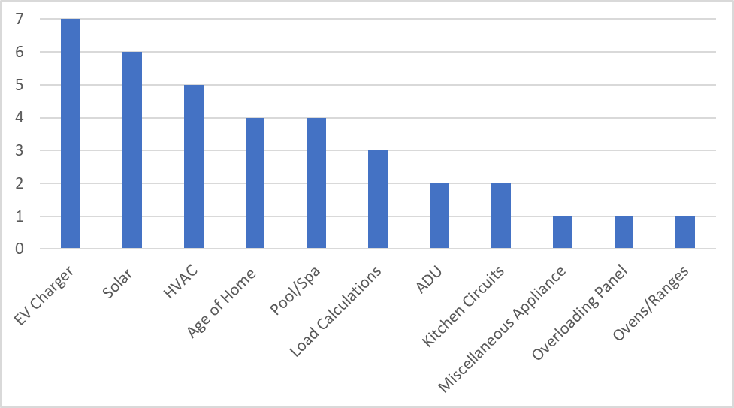
Figure 3: Electrician-reported reasons for service panel upgrades that trigger a Service Upgrade (N=36).

Electrical contractors consider if the home’s panel has breaker space to accommodate additional circuits, even though the calculations are under 100-amps. Spare breakers may be needed to increase a circuit from 120 to 240 volts. The contractor considers numerous factors in conjunction with the homeowner when determining the necessary panel capacity. One overarching consideration is the future intentions of the homeowner. If the homeowner plans to install an electric vehicle charging, solar PV, pool pumps and/or pool heat pump, new HVAC equipment, induction range, tankless water heater, home additions or ADUs, they are often culprits in causing an electrical panel to be upsized, and thus, the Service Upgrade.

Load Calculations are the fundamental factor that cause Service Upgrades. These are determined by the electrical code, but not all professionals or jurisdictions are in the habit of doing them with the goal of preserving the existing service capacity. Electricians must perform load calculations and commonly use the National Electrical Code (NEC) Section 220.83, or as per local jurisdiction requirements in the 30-Day load study per NEC 220.87. When adding only one appliance, the observed demand over a 30-day load study or a yearlong study is generally even lower than rigorous and accurate panel sizing calculations that Section 220.83 suggests. This is a more favorable estimate of peak load than the Load Calculations method or the Watt Diet, which is a streamlined Load Minimizer. When doing a full electrification retrofit with two or more appliances to fuel-switch, the NEC Section 220.83 method is often more favorable to keeping the existing panel.

In the case of EV chargers, some tankless water heaters and new HVAC installations, spare breakers may be needed to increase a circuit from 120 to 240-volts. Often, the need to upgrade to a panel with more breaker space leads to the homeowner or electrician suggesting the idea of increasing their service capacity at the same time to save time or expense later or improve home value.
For solar PV, the electrician considers the size of the planned solar installation. Busbars are commonly the limiting factor in a PV array size. If a customer wants more PV than the busbar can accommodate alongside the service panel, they go for a Service Upgrade. 5 kW DC is the average total residential solar installation size, and size is limited by available roof area and shape.

PV installers will often recommend a panel upgrade while onsite, and SDG&E staff reported that it is common for PV sales teams to submit applications for whole neighborhoods that they canvass prior to signing an agreement to initiate the Service Upgrade process. This results in Utility staff working on applications that will never become projects. Under these circumstances, a small percentage of these homeowners sign solar PV agreements.

HVAC upgrades are a common reason to upgrade a service panel when a home only has a gas furnace. This is common in many temperate climates in California where air conditioning is seldom needed, and in lower-income homes upgrading from window air conditioning units. If an air conditioning unit is present, a heat pump is normally able to utilize the same breaker as the existing unit.

Kitchen circuitry Changes to kitchen circuitry can be a simple, $500 job of installing a new circuit and wire, but the existing breaker spaces on the panel can mean that a Like-For-Like Panel Upgrade or even a Service Upgrade is necessary, especially in older homes.

Service Upgrades do not always happen because they are immediately required by the code, rather the contractor is trying to set the homeowner up for success later and avoid future roadblocks.

What alternatives are considered to alleviate the need for these upgrades?
Service Upgrades are triggered by a customer’s electric load requiring more service capacity. Alleviating the need for an electrical panel upgrade also alleviates the need for Service Upgrades. This section discusses the most effective alternatives to alleviate the need for an upgrade for the most common Service Upgrade triggers reported by the Utilities and contractors.

Avoid a Service Upgrade triggered by solar photovoltaics (PV) installation. One of the leading drivers for Service Upgrades in California is solar PV. Much of this category is driven by customer desire for a certain amount of energy offset along with available roof space and shape. Although the average residential solar installation size in California is 5 kW DC, cost-effective energy efficiency measures can help reduce the overall size of a customer’s PV offset. That in turn may allow more customers to size a PV system under the code limits of their existing panel, from 3.8 kW for 100-amp busbars, up to a maximum of 13.4 kW for 225-amp service busbars with a 200A main breaker. The electrical code (Section 705) prescribes that when a customer’s busbar rating is higher than their main panel rating, they can install more solar than if the panel rating and busbar rating were matched.

Another consideration is some solar inverters enable more PV capacity than the inverter outputs to the grid, meaning more capacity is available across the day. This is known in the industry as “clipping” and may reduce the AC nameplate size needed for the solar installation.

Avoid a Service Upgrade triggered by the installation of a 240-volt or level 2 EV charger.

As discussed in Section 2.1.1, electricians reported installing a 240-volt EV charger as one of the most common reasons for a panel upgrade and a resulting Service Upgrade, but it is one of the most avoidable. Many EV adopters overestimate the size of the EV charger they require. Customers who travel less than 20,000 miles per year in their commute can charge effectively from a 120-volt charger with the electrical outlets already found in the customer’s garage. A 240-volt charger is generally unnecessary. Avoiding the need to add a new 240-volt circuit can alleviate the need for a panel upgrade that triggers a Service Upgrade.

Several options existing on the market today that can share power between an EV and another device on the panel, such as the devices in Figure 4, which are all Underwriters Laboratory (UL) Listed. If the EV is the trigger for the upgrade, selecting one of these options would be much less expensive for customers than upgrading their panel.
Figure 4: Smart Circuit Products and Sharing Devices
Homeowners and contractors are unaware of alternatives. In general, electricians do not consider alternatives to alleviate the need for Service Upgrades, and homeowners are unaware of the possibility of doing so. Some electricians, especially if they are electrification professionals or if the customer is an electrification early adopter, will make the customer aware of some of the options available. Electricians who are not following emerging trends may be unaware of the options on the market.

Since most homes built after 1968 have 100-amp service, a panel upgrade is unnecessary. From 1965 to 1967, single family homes in California began to be require 100-amp electrical service, regardless of load calculations required. This means that there is a subset of older homes on less than 100-amp service, but there is also a high level of confidence that a home built after 1968 has at least 100-amp service already. If a 100-amp service is the baseline for an electrification retrofit, and it is possible to electrify the home on 100-amps, this means that those homes are already prepared without an upgrade. In some areas of the state, especially San Francisco, meters are being required to be moved out of garages and into publicly accessible space, which creates the need for a full review process whenever an electrical project needs to pull a permit. Figure 5 illustrates the relative age of the owner-occupied housing stock in California. Approximately 71% of homes should have at least 100-amp panels based on the year the home was built, and of the remaining 29% that were not required, any that added air conditioning would have since upgraded to 100A.
Figure 5: 2020 US Census data on the age of housing stock in California

Heat pump water heaters that will alleviate the need for a Service Upgrade. Almost all gas water heaters currently have a 120-volt circuit to the appliance, and this can either be upgraded to 240-volts or it can be kept on a 120-volt circuit to avoid some Service Upgrades due to insufficient breaker space. Almost all Heat Pump Water Heaters on the market are currently 240/208 volts, but the major manufacturers including Rheem and Haier are bringing 120-volt water heaters to hardware stores and plumbing distributors. These 120-volt standalone units are intended to be a near drop-in replacement for a standard gas-fired storage tank water heater, without requiring expensive 240-volt circuit upgrades from the currently available heat pump water heaters. The Nyle recently came out with the E-8 which is available for purchase at the time of writing in late 2021, uses low-GWP refrigerant, and makes use of the existing 120-volt line and tank from the gas water heater, drawing only a nameplate rating of 900 Watts.
Electrical panel sizing for a customer. To help prevent the need for some panel upgrades, a helpful tool is the “Watt Diet” Calculator which determines the size of a home’s electrical panel according to the code requirements. It does the load calculations that an electrician would do, with the goal in mind being to reduce the required panel size, which reduces the required service feeder size. An all-electric home with an EV charger can be as big as 2,000 square feet in most of California and fit on a 100-amp panel- so some electrification retrofits do not necessarily need a Service Upgrade. The biggest load impacts on a home’s electrical panel result from HVAC systems, pool pumps, and EV charging. However, methods exist to reduce these loads, like choosing high-efficiency appropriately sized HVAC equipment and utilizing power sharing devices that share a 240-volt circuit between an EV charger and dryer for example.

California Title 24 impacts in the common requirements for a Service Upgrade
California Building Code, Title 24, Part 3, is the electrical code for the state of California (also called the California Electrical Code, or CEC), and its current iteration is adopted from the National Fire Protection Association (NFPA), Section 70, National Electric Code — also known as the 2017 National Electrical Code (NEC), which is adopted by all 50 states.

The requirements include the primary set of panel load calculations that are part of the electrical code administered by the state, however, the load calculations are generally performed by the electrician in accordance with the city or county to get the permit to install the new or upgraded service panel. These calculations impact the Service Upgrade process by initiating the need for a Service Upgrade, and Title 24 Part 3.

California Building Code, Title 24 Part 6 — also known as the California Energy Code — is not addressed or included in the requirements for a Service Upgrade. However, Title 24 Part 6 began to require 200-amp main service for single-family buildings in the 2019 standards (Title 24 Part 6, §110.10(e)).

California Building Code, Title 24, Part 9 — also known as the California Fire Code — includes the following related to panel circuits or retrofits: If the electrician notices missing smoke or Carbon monoxide detectors, the electrician is required to install these. If there are outlets required to be Arc Fault Circuit Interruptible (AFCI) or Ground Fault Circuit Interruptible (GFCI) and the electrician notices they are not already, the electrician must install these as well.

Identify current processes in place to complete the Service Upgrades
This section discusses the current processes in place to complete the Service Upgrades for both SDG&E and PG&E from both the Utility’s perspective and the contractors. SDG&E, PG&E and contractors from both service territories provided processes, responsible parties, and timelines from their perspective. Although there are many similarities, the distinct differences will also be discussed.

SDG&E Service Upgrade Process, Responsible Parties, and Timeframe
SDG&E’s data request response provided a detailed 11-step process, responsible parties, and the timeline for the Service Upgrade process illustrated in Figure 7 totaling up to 17 weeks.
- From SDG&E’s perspective, the process starts when the customer applies for the Service Upgrade. The customer can call SDG&E to initiate the process or complete the process online. SDG&E creates a job package and assigns a fielding date which will take one to two days to complete.
- Over the next four to eight weeks, SDG&E fields the job and assigns the customer’s final submittal date,
- SDG&E then creates a service order which generates the Utility fees to complete the Service Upgrade and provides the job package to the customer in five to seven business days.
- SDG&E then contacts the customer over the next one to two days to verify they received the job package. The customer must then pay the Utility the fee and obtain a permit. Contractors reported this step takes between one day and a week or more to complete. If a right-of-way is required, it must be obtained at this point in the process. The customer must also schedule trench inspections as the trenching is fully the responsibility of the customer. SDG&E reported that these customer steps have timeframes that vary by project.
- Once all the requirements are met, SDG&E will take one to two days to schedule crews.
- Over the next two to six weeks, SDG&E completes the Service Upgrade work, the customer is energized, and the meter set is completed. Over the next one to three days, SDG&E completes their last step to reconcile the job in SAP and the job is considered complete.

Contractors that participated in the Study reported the Service Upgrade process from their perspective, which somewhat aligned with SDG&E’s reported process. The contractors reported a process with fewer steps and a shorter timeframe. Contractors reported the process commencing before SDG&E’s starting point, which is when the customer calls the contractor for a quote to complete the home improvements. The contractor will gather information to develop a bid and the customer signs a contract in between one to two weeks. The next step is the Utility issues a service order in the next two days to two months. The contractor then reports spending the next two weeks to six months coordinating with SDG&E to get a planner onsite. Contractors then obtain permits that typically can be done between one day and one week or more. The last step that the contractor reported is that they disconnect/reconnect and install the new panel with wiring and complete the job, which takes one day.

Figure 6 combines the information from SDG&E and the process and timeline data gathered during contractor interviews. Overall, the total Service Upgrade process is typically completed in up to ten months.

Figure 6: Overall Service Upgrade Process for SDG&E

PG&E Service Upgrade Process, Responsible Parties, and Timeframe
PG&E’s data response indicated a list of steps with the process and responsible parties with an overall timeline that is reported to be highly variable depending on circumstances. A job that requires no transformer upgrade can be completed in less than two weeks, whereas jobs that require a transformer upgrade and underground trenching could take four months or more.

PG&E’s Service Upgrade process is initiated when the customer submits a request online or over the phone. PG&E assigns a staff member (Job Owner) who has a conversation with the customer to understand the basic parameters of the project. The customer is then required to submit an engineering advance to begin PG&E’s engineering reviews of the project to begin. An engineer develops an estimate, and the customer signs a contract with PG&E for the work. The customer completes any work on their end such as trenching that must be completed and then PG&E inspects. The last step reported by PG&E is completion of the Service Upgrade.

Contractors report the Service Upgrade process starting with the homeowner calling the contractor for a quote. Over the next one to two weeks, the contractor gathers information, and they sign a contract. The contractor takes photos and submits them to PG&E as part of the online Service Upgrade application. Contractors reported the ease of using the online system, the time and effort saved by PG&E requiring photos to be submitted with the application and the time necessary to complete the application which is only 15 to 30 minutes. The contractor waits to hear from the PG&E representative over the next three days. The lead time up to 6 months was reported by contractors because two site trips are required. The PG&E rep will then call the contractor with questions if more information is needed. PG&E confirms approval over the next two to seven days. The contractor obtains the permit from the authority having jurisdiction (AHJ) which is reported to take between one day and four weeks. The contractor schedules a disconnect with PG&E that will be over the next five days to eight weeks. After a field visit to complete the AHJ inspection and a disconnect/tear down, PG&E reconnects the electrical, and the installation is complete. From the contractor’s perspective, the Service Upgrade process can be as little as two days and upwards of eight months from start to finish.

Figure 7 combines the information from PG&E’s data request response on the Service Upgrade process along with the process and timeline data reported by contractor working in the PG&E service territory. Overall, the total Service Upgrade process is typically completed within ten to 30 days but projects up to eight months were reported.

Figure 7: Overall Service Upgrade Process for PG&E

PG&E and SDG&E Process Differences
There are two significant process differences between the PG&E and SDG&E Service Upgrades that may contribute to a more streamlined process for SDG&E. These include: (1) requiring load calculations to be submitted in the initial application and (2) having an online system that requires photographing the site in the initial application.
For PG&E Service Upgrades, the Applicant, either the customer or the contractor, are required to upload site photos as part of the initial application. However, SDG&E requires a planner to physically visit the site to create a permit number. PG&E contractors reported it took 15 to 20 minutes to take and upload photos into the PG&E application system. Conversely, contractors reported that coordinating with SDG&E to schedule an on-site visit with a Utility planner can add weeks to the process. The required physical site visit adds time to the process and cost for the Utility and customer.
PG&E staff and contractors reported that applications have a 30-day clock reset. If a period of 30 days passes without further customer documentation being received by PG&E, the Service Upgrade application is closed and canceled. This means that in some cases where permit acquisition or design work takes longer than 30 days, a customer must resubmit a new application. Utility staff and customer time and money is lost. Utility staff indicated that customers are frustrated by this outcome. No customer survey respondents reported this specific issue. This is a distinct difference by PG&E and SDG&E.

SDG&E requires the contactor to coordinate the entire process with SDG&E and the city, including the disconnect and reconnect. It is the contractor’s responsibility to make sure the city inspector and SDG&E crew are available at the same time. One contractor reported that SDG&E only has two crews in their area for this process which makes coordinating even more difficult. The contractor coordinates with city inspectors to inspect the panel after the grounding is done. Then the inspector calls SDG&E to reconnect the panel, but if the inspector cancels that day SDG&E charges the customer $750.
PG&E contractors reported coordinating issues with the application process rather than the onsite process of waiting for the installation date that takes about four to eight weeks. It was noted the PG&E delay was due to rescheduling due to weather. PG&E contractors reported if erroneous information were provided, or PG&E wants different information for the application it would take the PG&E rep five to seven days to respond instead of 24 to 48 hours. Another contractor reported not hearing back for over a week, and has lost jobs due to the time it can take to coordinate with PG&E.

Customer feedback on the Service Upgrade process
Customers reported on their experiences, education throughout the process, and challenges they encountered. Approximately 54% indicated some major challenge, with the majority reporting significant delays from the Utility and some delays with the local permitting office. Most delays revolved around the initial Utility inspections and Utility staff response time, with some customers receiving responses weeks after they reached out to the Utility.

Many of the customer responses indicated that the entire process was very confusing and took months longer than estimated by the Utilities, which also increased the financial impact related to the Service Upgrade due to the duration.

The Utilities report consistently looking for ways to improve the customer experience. This is certainly an area worthy of the Utilities’ time and effort to streamline and improve upon.

Understand costs incurred by all parties

Identify typical costs associated with increasing electrical capacity for residential electrification retrofit projects and the parties responsible
The typical costs associated with increasing electrical capacity in residential retrofits fall into three categories – Utility Service Upgrade costs, customer-owned equipment costs, and other miscellaneous project costs which may apply. The total cost for all three categories was reported to range between approximately $2,000 to well over $30,000 or more.

Utility Service Upgrade Costs
Rules 15 and 16 govern the allowance for Service Upgrades totaling $2,154 for PG&E and $3,241 for SDG&E, which is the amount the utility initially covers on behalf of the customer, as filed in rate case proceedings. However, a Utility contractor reported that despite the Utility supplying the materials for service upgrades — wire, conduit, pole changeouts, and transformer upgrades, etc. potentially paid by the customer to the Utility — the cost the contractor would bill the Utility may still range between $2,000 and $30,000 for the labor, excluding any customer owned equipment.
Those material costs may also be passed onto the customer in certain circumstances, such as in the case of a transformer replacement. Utility SMEs and data request responses reported that if the transformer needs to be replaced and upgraded, the homeowner bears:
- 100% of the cost if they are the only home on the transformer
- 50% of the cost if the transformer is shared with another property
- 0% of the cost if it is shared between three or more properties. In this case the Utility bears 100% of the transformer upgrade cost.
The average costs reported by the contractors is shown in Table 3 below. However, as the Utilities did not provide their actual contractual Service Upgrade costs due to privacy reasons, these costs were reported by electrical contractors who have performed work on behalf of the utilities in the past.
Table 3: Utility Service Upgrade Costs for Utility/Public Right-of-Way Property
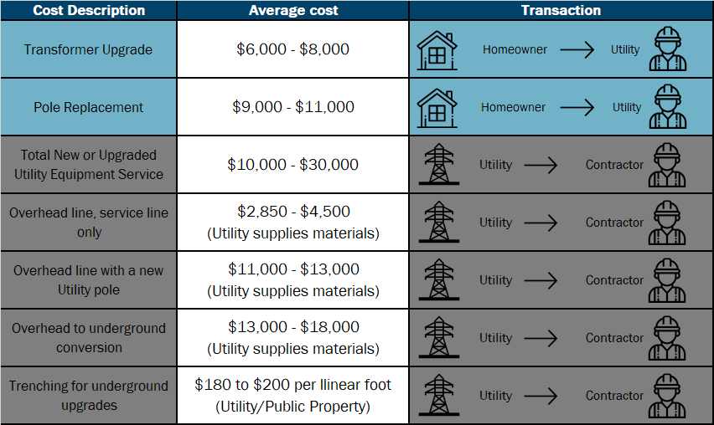

Customer-owned Equipment Costs
Customers are responsible for electrical panel upgrades with costs ranging between $2,000 and $4,500 with an average cost of $2,780 as reported by electricians. This cost does not include additional customer costs incurred if they are responsible for any portion of Utility infrastructure — pole changeouts, transformer upgrades, conduit replacement — or other costs such as sub-panels, excessive run distances, new breakers, trenching, etc. All together, these costs can range from $3,000 to more than $18,000.
Overhead to underground conversions or panel relocations on the homeowner’s property typically resulted in costs ranging between $3,000 and $10,000 on average, compared with the average overhead service upgrade cost range between $2,000 and $4,500.
Table 4: Customer-Owned Equipment Service Upgrade Costs
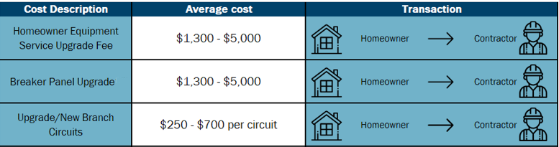

Other Miscellaneous Costs
Other Service Upgrade related costs the customer may typically be responsible for, but not limited to, include trenching, permits, easement costs, conduit replacements, grounding, taxes, and other design or application fees. Additionally, costs may be incurred due to errors in the process, as reported by one homeowner who was instructed to relocate the gas meter, then once that was paid for, was told that it had to be moved to yet a different location, resulting in more expenses incurred.
Table 5: Miscellaneous Service Upgrade Costs
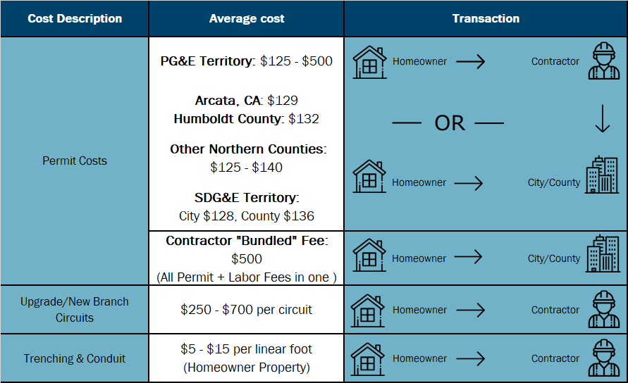

The total cost for a Service Upgrade as reported by homeowners in the survey results is shown in Table 6 below.

Table 6: Total Cost of Electrical Service Upgrades as Reported by PG&E and SDG&E Homeowners
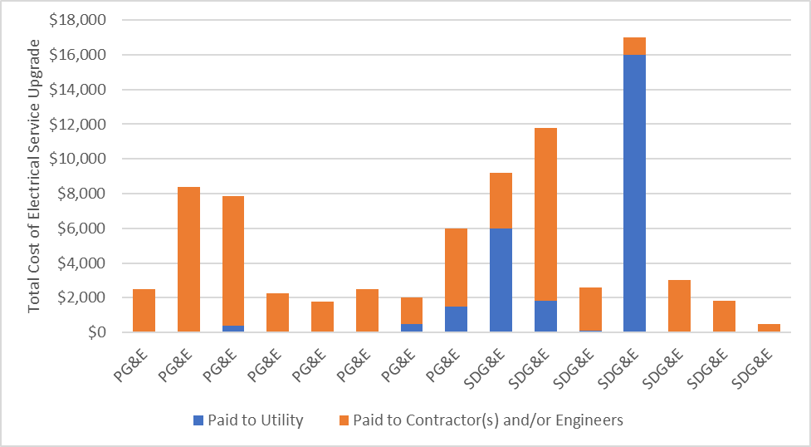

The outlying respondent in Table 6 that reported a $16,000 total cost for the Service Upgrade had the following statement about the major challenges faced during the Service Upgrade:
“Inspection prior to start by SDGE was flawed. She told me I had to move the gas line prior to being able to upgrade my power panel. I paid $1,002 dollars to move the gas line and when she came back, she said there was another issue with the gas line, and it would have to be moved again. She had a person with her who was 'in training' and she was supposed to be the trainer? Completely unnecessary and additional cost on the project (along with delays)”

Identify and explain factors that may impact these costs
Several single-family home contractors noted that their long-standing price estimates are far different now since the COVID-19 pandemic has impacted the economy. Due to supply chain disruptions and manufacturing and shipping delays from the pandemic, material costs have increased significantly, which has resulted in material costs becoming the dominant cost in Service Upgrades. A contractor stated that “Labor used to be the main cost with materials nearly insignificant, but with the cost of wire and materials increasing in the last 12-18 months that percent has changed dramatically.”

Contractors reported the top variables that increase or decrease the cost of a Service Upgrade or upgrading a customer’s breaker panel: (1) panel location and its distance from the electrical pole, (2) street line connection, and (3) transformer. Additionally, contractors reported other variables including the proximity to gas lines that must be six feet away, material costs and lead times, labor costs such as local cost of living, façade work such as stucco or brick, trenching, and amperage of panel upgrade.

When asked about the barriers typically resulting in additional cost to complete a Service Upgrade, contractors indicated the size of the panel. The larger the panel, the more time and cost barriers. Another barrier is if a gas riser is too close to the panel, it cannot be upgraded to 200-amp. This will require a mechanical contractor to move the gas line. Finally, underground conduits and Utility representatives taking five to seven days to respond instead of 24 to 48 hours as indicated is a barrier.

Conclusions and Recommendations
This section summarizes the conclusions from the Study and recommendations for future activities.

Conclusions

Current State of Service Upgrades

Customers lack education and support during the process
General customer responses indicated the process takes longer than expected and requires a lot of Utility review. Customers are often surprised to learn that they must pay a fee to the Utility for a Utility infrastructure upgrade. Furthermore, they are typically unaware of the Rule 16 allowance. Customers that complete Service Upgrades are confused about why the process is longer than expected and there seems to be a lack of clear expectations.

Successful customers often have an advisor explaining the process and requirements prior to submitting the application. Reliable advisor sources are experienced electricians, Utility staff members, and Utility contractors.

Like-For-Like Panel Upgrades do not increase service capacity and, therefore, do not require a Service Upgrade. The most successful customer applicants have a Like-For-Like Panel Upgrade. Customers that are increasing service capacity require a higher level of review.

Conclusion: Customers who successfully complete a Service Upgrade quickly tend to have an educated advisor or educational support, such as experienced contractor, Utility staff member, or Utility contractor who can explain and support the complete process. More effective initial education for contractors and setting clear expectations early with customers will result in a significant reduction in the time required to complete a Service Upgrade.

Timely project communication can be improved
There are various customer touchpoints in the Service Upgrade process that require Utility communication with the applicant that can improve the overall timeline.

Utility Communication with Applicants. Communication with applicants is the number one use of staff time, as opposed to project review. This is due in part to the Utility staff practice of contacting each customer by phone call with updates to their application throughout the process. Customer-facing project tracking software can be leveraged instead, to notify customers of the stages and progress on their application automatically. Status calls take time away from processing applications, resulting in unnecessary project delays.

Incorrect Submission Applications. Staff respondents indicated that there were more issues with applicants seeking to have a new service installed compared to those who indicated that they were having a Like-For-Like Panel Upgrade. This occurs because there is more engineering and design work required whenever a customer increases their panel capacity — the service line and transformer must be inspected and a determination about whether there is capacity to service the higher load. These are different categories with different departments serving the request, and a new service request is categorized as either an increase in service or a new service drop. That means that the initial information that the customer provides is sometimes insufficient or incorrect and the Utility staff member must spend extra time obtaining that missing or incorrect information in initial application if it has been misrepresented as a Like-for-Like Panel Upgrade.

If the homeowner is submitting the incorrect type of application, in many cases, when the application needs to be rejected due to missing information after initial review, the homeowner is unprepared for the follow up paperwork that is required and is unprepared to play the role of Project Manager.

Conclusion: Clear communication and setting expectations with the customer early in the process has been a successful method of improving application processing time and increased initial education for customers with what they need to succeed will improve timeframes and outcomes.

Residential solar contractors are prematurely submitting Service Upgrade applications to SDG&E
Some SDG&E SMEs reported that solar companies are submitting Service Upgrade applications on behalf of customers that the solar companies have not spoken to, or who may have indicated a passing level of interest in a PV system. These solar companies are drastically increasing the workload of Service Upgrade Utility staff for a relatively small proportion of actual applications. Utility staff must then take the time to investigate each application as if it was a genuine submission, taking away resources from actual applications with serious customers.

Conclusion: SDG&E’s application requirements need to be enhanced to prevent solar companies from prematurely submitting Service Upgrade applications to ensure Utility staff is processing contracted projects.

Contractor workload increasing from electrification without efficiency education
Electrical contractors who work with utility customers, are primarily seeing an increase in work from EV charging and solar PV installations, while electrification/decarbonization and whole home improvement contractors who work with utility customers are seeing a larger increase in work from heat pump space conditioners, heat pump water heaters, and EV charger installations.

Electrical contractors have limited awareness of electrification and decarbonization as a market trend or a source of work for them. Electrical contractors are less likely to suggest alternatives to Service Upgrades or appliance retrofits for electrification purposes when focused primarily on PV or EV charging work.

Conclusion: Electricians, who work primarily with customers, are unaware of the efficiency or load-sharing options available to mitigate Service Upgrades during retrofits, and instead resort to upgrading a panel capacity, and thus a resulting service.

Utilities need more resources
Contractors and customers reported that the long timeline for Service Upgrade completions due to Utility delays and customers are generally dissatisfied with the current project durations. Increasing the quantity of Utility staff available to do inspections and field work, application reviews, and engineering designs will substantially reduce the current length of time.
“Before solar: The [Utility] had good, staffed crews. Post solar: now one [Utility] crew has all new solar projects and all panel upgrades, and panel upgrades get delayed; Need two different crews or crew types: one for solar installations and one for panel upgrades.”

“About 10 years ago (before the increase of solar) it took 3 days to obtain a workorder.”
Utility staff also reported that construction resources are retiring faster than new crew members can be hired, so there is an increasing bottleneck factor due to the labor market for Utility crews and contractors. PV/Solar rooftop installations are increasing and are almost always associated with a service upgrade request – even if the specific project does not technically require one, the solar contractor applies anyway.

Conclusion: The number of solar photovoltaic installations has continued to rise over the years and there are now many more factors triggering Service Upgrades that require Utility staff time for application processing, inspections, and connection. The Service Upgrade department is likely understaffed and even more likely under-equipped to meet the demand for Service Upgrades, which will continue to increase as customers move to the increasingly required or simply desirable electric equipment.

Electrification Upgrades

Electrification retrofits and mitigation of potential Service Upgrades
An electrification retrofit does not necessitate a Service Upgrade in many homes. Products such as 240-volt consumer-grade devices like the “Simple Switch” and “Neocharge” may be options to avoid Service Upgrades while adding 240-volt loads. In homes with a lack of spare circuit breakers, the UL-listed circuit sharing devices, smart panels, and UL-listed smart circuit breakers can be deployed to share power between devices. These devices that do not typically have coincident load, such as EV chargers and washing machines, can avoid the need for a Service Upgrade. However, of the contractors interviewed, none were aware of these options other than those who specified that they were “electrification contractors” who indicated that they were pursuing ways to avoid Service Upgrades for their customers.

Conclusion: While whole home electrification contractors may be aware, most other contractors and customers are unaware of options to mitigate the need for a Service Upgrade entirely.

Continuing and Future Trends in Service Upgrades of all Types

Continuing Trends
Increase in Applications as Electrification Adoption Grows
Residential electrification upgrades and Service Upgrades typically run a similar course to many home improvements from the customer and contractor perspective. They will work with the Utility to shut off power to the panel if it needs to be replaced, and if it needs to be moved or upgraded, they will work with the Utility to increase the size or move the service drop.

Electrification retrofits will most likely lead to an increase in Service Upgrade applications for the Utilities in the future, as more jurisdictions investigate all-electric code options.

Utilities can help reduce confusion by educating customers and contractors about ways to mitigate the need for a Service Upgrade, and the benefits of electrification seen by early adopters currently. The Utilities can also prepare for the change internally to streamline the Service Upgrade process along with options to increase customer education, costs involved, and ongoing status reports.

Conclusion: As electrification adoption increases across California, the need for increased customer and contractor education on the Service Upgrade process, including ways to mitigate the need for an upgrade, is imperative.

Utility Contractor Availability
There is a reported lack of Utility lineman in California according to Utility staff and contractors, which is projected to increase as the existing workforce retires.

Utilities contract with private entities to complete the Service Upgrade work. Utility staff and contractors reported that Utility contractor crews’ schedules have been mismanaged. As an example, one crew had no work for over a month, even though the crew was available to work and there was a project backlog. When contractors have inconsistent work, lineworkers must seek employment elsewhere. In a competitive job environment, the Utilities lose resources.

Conclusion: More effectively managing the workloads of qualified contractors will continue to be essential to meet the increasing demand for Service Upgrades.

Future Trends
Utility staff had mixed thoughts future trends for Service Upgrades. Some felt that there is an issue of pent-up demand for Service Upgrades, while others felt that solar will increasingly lead to Service Upgrades. They are not seeing a rise in applications due electrification but are seeing a rise in applications due to additions, ADU’s, and Solar PV.

Residential buildings do not need a 200-amp panel to install solar, however, solar contractors upgrade service panels on most projects. The customers that need a PV array above 3.8 kW DC are also likely to be the customers that install a 200-amp panel regardless of the cost.

Conclusion: Utility staff are not seeing a rise in application quantities due to electrification but are already seeing a rise in Service Upgrade applications for other reasons.

Recommendations
Based on the findings of this Study, the Study team recommends the Utilities, CPUC, and future program implementers consider the following recommendations.

Recommendations for Utilities
Utilities should investigate leveraging the overhead to underground conversion allowance for Service Upgrades that are required to convert overhead to underground lines.
This allowance would mitigate the increased costs faced by customers who are upgrading their electrical equipment with existing tariffs and budgets for fire hardening programs. The overhead to underground conversion provides a fire hardening benefit for existing customers not currently scheduled.
Utilities should continue to assess ways to reduce the need for Service Upgrades.
Increasing customer and contractor education on ways to mitigate Service Upgrades, may increase electrification adoption due to less risk of a costly Service Upgrade during the project. It will decrease the demand for Service Upgrades for the line to the customer. Many single-family homes in California can go all-electric with a standard 100-amp service drop, and it would be in the customer’s best interest to investigate ways to prevent the need for a Service Upgrade entirely. The cost of an upgrade can be upwards of $5,000 depending solely on materials and labor costs, and over $18,000 if transformer, pole, and line upgrades are needed. For instance, adding a high amperage heat pump water heater can be avoided with a lower amperage model – and the existing service drop can be used to deliver the needed power. Because the cost of a Service Upgrade is high to the individual and the ratepayer, it is worth a basic inquiry to determine if a Service Upgrade is necessary in all cases.
A key factor is assisting the homeowner and contractors to make informed choices dependent on their personal situation. Approximately 71% of California Single Family homes have at least 100-amp service entrances based on California electrical code changes in the mid-1960s and the 2020 US Census data and historical building codes.
Continue to educate contractors and customers on the availability of both energy efficient and low-amperage products.
There is a knowledge gap and an awareness gap around efficient low-amperage products and panel size suitable retrofit options, however, not necessarily a product gap. The Utilities have been doing a great job promoting energy efficiency and education among customers and contractors, so it is crucial to continue those efforts while also increasing awareness of new products which may alleviate the need for a Service Upgrade during a retrofit.
Consider offering a bonus incentive to customers completing electrification retrofits that do not significantly increase their amperage.

Although the focus on lower amperage units instead of simply “efficient” units may be untraditional, it will be more cost effective in the future with new avoided costs, increased natural gas costs, and total system benefit inclusions into cost effectiveness.

Develop and share Utility-specific best practices.
There are differences between the PG&E and SDG&E Service Upgrade processes that drive efficiencies such as requiring load calculations and site photos as part of the initial Service Upgrade application. The Utilities will benefit from developing and sharing best practices and lessons learned for the customer application intake, requirements, and scheduling that will support process improvements. The goal of the process improvements is to support Utility staff to more efficiently complete Service Upgrades, reduce the overall timeline, improve customer communication, and reduce costs.
Streamlining Utility software, including providing automatic notifications to the customer and staff would improve Service Upgrade review time.
If Utility software can show Utility staff the stages which an application has passed through, it should be able to provide updates to the customer applicant in the form of an email or a text, customer preference depending. This would save staff time spent reaching out to customers, sometimes in a redundant fashion because the customer has already seen the update in their portal.

Service Upgrade applications should continue to have one central, Utility-facing portal or document hub for each applicant that is accessible by the key staff for the application including: the planner, the inspector, and the design team. This saves staff time spent corresponding about documentation.

Educating the customer on the steps that the Service Upgrade process will take is crucial prior to submitting the initial Service Upgrade application to the Utility.
Customers that received early guidance with clear expectations of costs and fees are much more likely to complete their Service Upgrade in a timely manner and reduce Utility staff time involved in sending applications back for review or corrections.
Utilities should investigate the potential for customers to receive educational materials such as a guide, video explanation, or infographic explaining the steps and documentation they will need to get an upgrade prior to submitting an application. These should remain accessible in their applicant portal and on the Utility website. It should set realistic expectations and clearly state common issues or process delays that may result, such as the fact that misrepresenting their installation of a larger panel as a Like-For-Like Panel Upgrade will create delays in their application.

Contractors should go through a separate training path of materials and available online education resources that goes into more depth — they are often the entity submitting the application on behalf of the customer. Educational materials for contractors on this topic should remain available in the Utility education as an On Demand module and updated if there is a major change.

Assess customer touchpoints early in the Service Upgrade customer journey to identify ways to educate the customer on ways to mitigate the need for a Service Upgrade.
The first customer touchpoint is the Utility website. This is a good opportunity to provide customers with information on how to avoid a Service Upgrade. Another customer touchpoint early in the process is the onsite Utility inspection. Utility inspectors can assess the need for a panel upgrade and provide a report to the customer. Utility and Building Department inspectors will need additional training to assess the need for a panel upgrade and provide the customer with a panel report. A leave-behind informational brochure may be another way to provide customers with information about their options to avoid the need for a panel upgrade and save the customer money.
Applications should not lose all submitted documentation and have the “clock reset” after not hearing back from the applicant for time periods longer than 30 days.
According to our interviews with staff, applications submitted to PG&E void after 30 days have passed from initial submission if the application is incomplete and the applicant has not followed up. Until all documents are submitted correctly, the application isn’t in the queue. This often results in Utility staff spending additional time reviewing documentation that has already been reviewed by someone else simply because some parts of the customer’s application were incomplete or incorrect. The study team does not believe that the current practice, which is to create a 30-day period in which all documents must be submitted, is as effective as using a two-track system. Creating an option to “freeze” and extend the documentation retention period, after the 30 days expire, for some period approximately six to nine months -- while allowing the applicant to pick up where they left off — may be a more efficient method to ensure eventual customer follow-through and completion. It also means that staff time spent processing the application is an effective use of time if the customer picks up where they left off later.
A lack of customer response may be due to unforeseen factors limiting their ability to respond within 30 days. Currently, the application restarts from scratch, which expends both staff and applicant time at no benefit to the customer.
Assess and leverage existing resources.
Utilities have Lean Six Sigma or other internal organizations tasked with identifying process improvements. Consider leveraging these continuous process improvement resources to assess and report on the Service Upgrade timeline, process automation and system upgrades.

Incorporating Service Upgrades and recommendations into electrification programs
Low amperage products have load profiles comparable to baseload profiles than high amperage products.
These products run longer at a lower amperage and may have potential to reduce the “duck curve” impact as more electronics and electrification alternatives are installed in homes. Well-chosen low amperage appliances, especially in HVAC and domestic hot water, do the same work as a high amperage at similar or greater efficiency, but at a demand that is more predictable as baseload power as opposed to peak power.
Leverage demand response (DR) programs to include an incentive for avoided upgrades, or the increased use of low-power appliances.
Options exist in the market which already provide a distributed incentive structure for customers to turn off high-amperage appliances and save power during DR and high-load events. This platform could be leveraged to educate and provide non-rate-based incentives for customers looking to electrify their appliances. Typically, marketplace DR options may compete with Utility run DR programs, which adds confusion among customers and would have to be coordinated.
Time-of-Use (TOU) rates can provide a market incentive to choose a low-amperage device, but for many customers, an education and knowledge gap exists around the problem caused by choosing energy efficient appliances which are “high-amperage,” or “power inefficient.” Despite customers focusing on efficiency, it may result in a relative increase in DR events as customers opt to electrify, as opposed to a market where customers have a signal to purchase devices that are both energy efficient and low-amperage. This lack of education and signals also may result in customers dissatisfaction from considering themselves “energy efficient” while still utilizing high-amperage appliances at peak times, resulting in increased Utility bills relative to a low-power energy efficient customer.
Incentives for low-amperage appliances and/or circuit sharing devices may be a beneficial intersection of equity and keeping ratepayer costs low.
The following list of potential opportunities should be considered as initial options for inclusion into future program or incentivized offerings:
- 120-volt heat pump water heaters
- 120-volt stovetops and ranges
- 120-volt ductless mini-split heat pumps (HVAC)
- EV, circuit sharing devices and smart circuit breakers
- “Smart” electrical panel upgrades

Pilot programs for a gas to electric conversion should be investigated by the Utilities as a non-resource option, with the future conversion to a resource program based on changes to total system benefit calculations.

The Study team understands the next round of ratepayer funded and CPUC approved third-party programs is already anticipated to provide incentives in this area of concern, and pilot programs would increase visibility and awareness on the issue.

Recommendations for CPUC
Investigate reallocating the existing incentives and allowances in Rules 15 and 16 for new natural gas connections to Service Upgrades. The CPUC has already begun to address this topic via Rulemaking 19-01-011, while also increasing the Rule 15 and 16 allowances to provide some incentive for overhead to underground conversions, which are becoming more often unavoidable under Rule 2.
Consider creating an incentive for Like-For-Like Panel Upgrades. The CPUC should consider Silicon Valley Clean Energy’s structure which financially incentivizes everyone to have 100-amp service but reduces the existing incentive available for upgrading to 200-amp at a progressively decreasing level based on customer income, while increasing customer education about “power efficient” appliances, load balancing devices and smart panels for 240-volt appliances.

This is a strategy that would help lower income homeowners and provides for the fact that “smart” electrical panels and UL-listed devices such “smart devices” can mitigate the power requirements that could otherwise drive a major shift towards 200-amp service in all residences. Smart panels could be incentivized, but a manufacturer requirement is that the security of the equipment’s firmware must be maintained for the life of the device.

The CPUC should highlight Utility efforts and best practices related to completing home upgrades without significant capacity increases, a panel upgrade, and Service Upgrades, including educational resources and support provided by the utilities. These efforts will help motivate customers who may be reluctant to pursue an electrification upgrade, while also educating other Utility staff on best practices across the state.

Recommendations for Future Studies
Future studies of this topic are recommended as study targets:

This Study gathered data from electricians and contractors contracted directly with the customer for the electrification retrofits. The Study team assumed these electricians and customer-contracted firms would have detailed cost data on the Utility costs associated with the Service Upgrade. The customer pays the Utility directly for the Service Upgrade costs that exceed the allowance. A future study must determine a way for Utilities to anonymize the Service Upgrade cost data so that their verified Service Upgrade cost data can be released. Future studies should consider allocating four to six months for the Utilities to respond to data requests to obtain actual Service Upgrade cost data.

In lieu of the Utilities’ actual Service Upgrade cost data, a future study could offer an increased incentive amount to several key Utility contractors to obtain several “sample bids” or hypothetical full project scenarios and cost breakdown. This would include example projects including both 100A to 200A upgrades and 200A to 400A upgrades, as well as overhead and underground projects. The contractors interviewed included both customer-facing and utility-facing contractors, but only utility contractors are able to provide data on the utility infrastructure costs that customers may be responsible for, and their data is proprietary but not inaccessible.

None of the participating contractors shared Service Upgrade cost data in the form of bids. The Study team received bids from full-service electrification professionals with panel upgrade costs, but they excluded the Service Upgrade cost data needed for this Study. The Study relied entirely on the Service Upgrade cost data reported by customers and a few contractor interviews that provided high-level Service Upgrade costs.

PG&E and SDG&E sent emails notifying customers of the upcoming Study before the survey and interview invitations were sent. A second round of emails was distributed to customers which provided an initial boost to response rate due to the customers’ familiarity with the Utility vs the Study team. A later email was distributed to PG&E contractors and provided a significant boost in response rate compared to cold calling alone. Our dataset was smaller than expected for the number of homeowners because the initial list was reduced by more than half due to Do Not Call lists and incorrect contact information. A 25% response rate to an email survey would be an ambitious goal to a future study without this support from the Utilities.

A future study could look more closely at the housing market and develop a statistical model of the number of homes that cannot avoid a panel upgrade from 200-amps or 400-amps.
- Much of this data already exists in the form of US Census Bureau data on the age and size of homes. From there, classifications of homes based on size, climate, and age can be compared to an extensive database of electrification retrofits. Determinations can then be made about the number and types of homes within study territories that the Utilities can expect to need an unavoidable Service Upgrade.
The Study team was able to get a higher response rate from its network of professional contacts, including many electrification professionals who are working on moving customers away from gas, than it got from cold calls to electricians or customers.

Appendix
The final draft of this report will include anonymized customer survey, contractor interview, and Utility staff interview data.

Customer Online Surveys
Full datasets will be made available to the Utilities, and selected questions are displayed below to protect customer privacy and PII. The full survey results graphics will be provided as a separate PDF document with this report.

Figure 8 - Customer Survey Q1
Question 1: What triggered your Utility electrical Service Upgrade? Check all that apply:
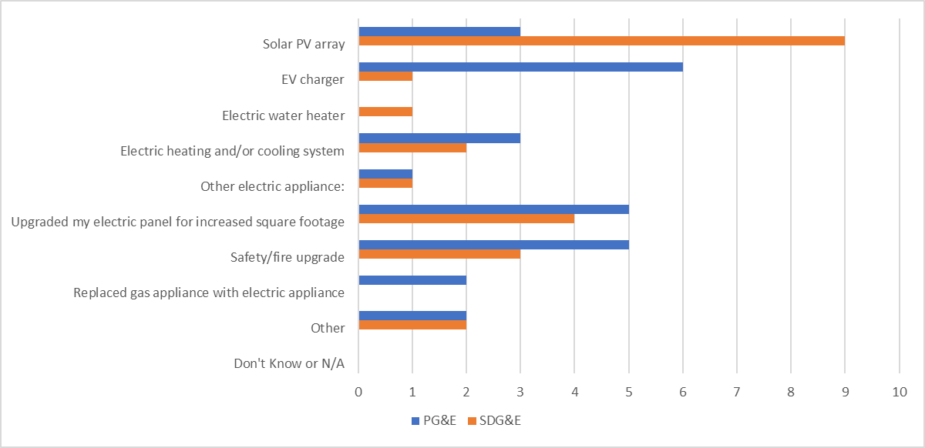

Figure 9 - Customer Survey Q2
Question 2: Did you consider any alternatives to alleviate the need for your Service Upgrade?
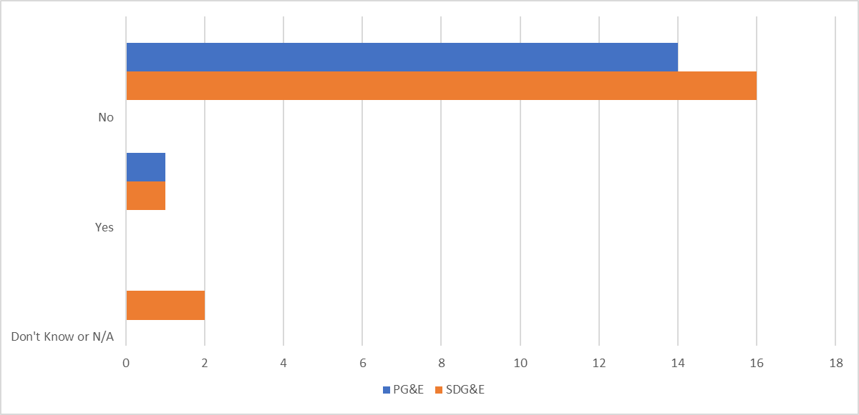

Figure 10 - Customer Survey Q9
Question 9: Approximately how long did it take from when you or your contractor first contacted your Utility to when you had the Utility electrical Service Upgrade completed?
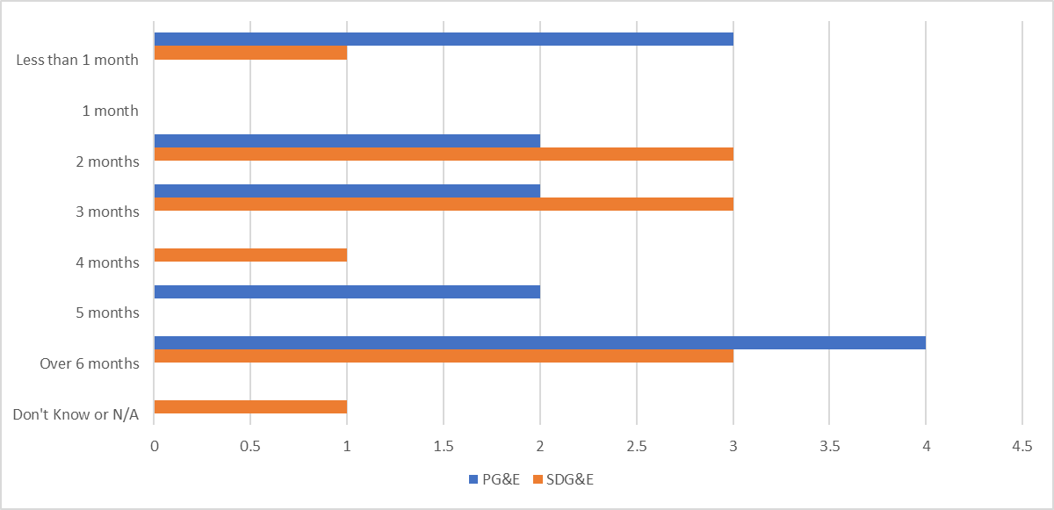

Figure 11 - Customer Survey Q10
Question 10: How did you find out the Service Upgrade would be necessary to complete your project?
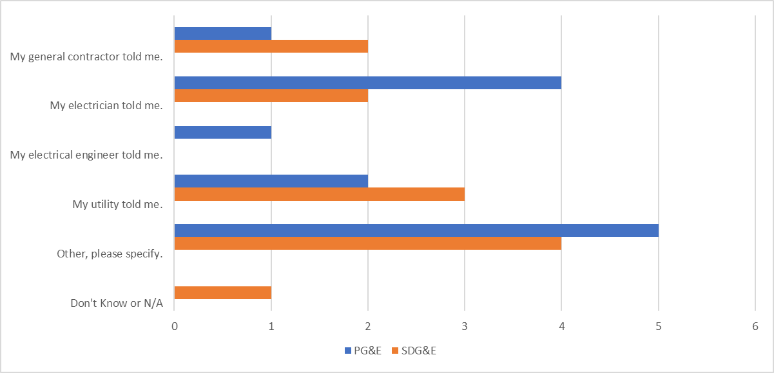

Contractor Interviews

Electrical Contractor Interview Data
The full contractor dataset will be provided to the Utilities in an Excel spreadsheet with the final report.

Case Studies with Electricians and Electrification Professionals
Case studies have been anonymized prior to public-facing publishing.

Case Study 1: California Electrician and Company Owner A
This electrician serves all of San Diego County and takes large jobs elsewhere in California and Arizona. The owner kindly agreed to an interview and explained Service Upgrade pricing, which is condensed below:
Q1: What is the range of prices you charge for Service Upgrades, and how do you price the tasks?
Company Owner A: “The upgrade of an existing 100-amp overhead service to 200-amp service is around $3,200. Of that total cost, $1,800 to $2,200 is just the service panel, and that if it’s just stucco siding, but this number goes up exponentially if there is brick, wood, or trim repair work around a panel. The riser may also need work.
While every city is different, roughly $700 of the $3,200 is costs related to permitting. The permit itself in this example is $250, plus $150 for two hours of labor at City, so $400 total. When the City comes out to inspect, we must set aside a 4-hour window, so at $75 an hour that waiting around costs $300. That’s where the $700 cost comes from.”
Q2: In your experience, what are the most common home improvements (or combination of home improvements) that trigger a Utility electrical Service Upgrade?
Company Owner A: “Adding a solar array, enlarging the house, building an accessory dwelling, or installing a pool or hot tub.”
Q3: What is the process for working with the Utility when upgrading a service?
Company Owner A : “Fill out the application, call the coordinator, check with project manager to set dates, call the City, pay for permits, align the dates that SDG&E is available, call in to the City Inspector 2 days before my disconnect date and let him know its urgent (it’s a disconnect reconnect), have Inspector online with SDG&E, then give SDG&E the OK the morning of the disconnect/reconnect. Arrange everything with inspector to be complete before 2pm. Have him release the meter to SDG&E. Then SDG&E has their crew out before 4pm to reconnect.
10 years ago, this would have taken roughly three days with an SDG&E project manager to arrange for a work order and disconnect date. Today it takes up to 25 days with the project coordinator, and another ten business days for the workorder.”
Q4: Do you feel that there are ways to streamline the Service Upgrade process for the customer’s benefit?
Company Owner A: “Before solar, about 10 years ago, SDG&E had good crews. Post solar, the same crew also has all the new solar rooftop projects, and crews are not coming out to reconnect services as quickly. The solution could be assigning Lineman just for solar, and [a] different crew for panel upgrades.”

Case Study 2: California Electrician and Company Owner B
Q1: How do you price Service Upgrades?
Company Owner B: “Each service must be looked at separately as each one, depending on age, will present different challenges. Some have panels recessed in the wall, some have panels under the residence, others may have multiple non-code complying wiring attached that must be corrected while doing the service change. Costs [in Humboldt County] can range from a super simple [panel] replacement at $750 all the way up to $2,000 for a 200-amp complex service.”
Q2: What is the split between labor and materials?
Company Owner B: “With material prices escalating so rapidly over the past year due to shortages, [2021] pricing may not reflect actual costs of service changes in the future once we emerge from the pandemic. Every service presents different scenarios that will affect labor and materials required to complete the installation.”

Case Study 3: Former California Utility Employee

A Former California Utility Employee avoided a $16,000 underground Service Upgrade bill from the Palo Alto municipal electric Utility while electrifying their 2,200 square feet, two story home. The Service Upgrade was avoided by using “power-efficient appliances, on a budget, in little experimental stages.” Company Owner C previously provided a training at the PG&E Energy Education Center on methods they used to achieve full electrification retrofits on 100-amp service, in dozens of stellar homes.
Former California Utility Employee’s first project, an original 1940’s home, had a previous Service Upgrade in the 1990’s, so the existing service’s “power budget” was 150-amps. By performing the electrification work themselves, and with the help of “buddies,” they spent only $6,400 to replace their gas water heater, furnace, stove, and laundry dryer. Had they installed new gas appliances, instead of electric, the budget would have been $1,400 cheaper, at $5,000.
The additional cost of new all-electric appliances was $1,400, but had they also performed a $16,000 Service Upgrade the additional cost would have been $17,400. So, by avoiding a Service Upgrade even though they wanted to go all-electric, the Former California Utility Employee was able to save $16,000. The electrification measures and costs are itemized in Table 7 below.
Table 7: Example Electrification Measures at an example home
Appliance | Type of Cost | Cost | DIY Labor Hours | Specifications
Heat Pump  Water Heater | Appliance | $1,200 | 4 | 50 Gal. HPWH from Lowe’s
 | Electrical | $150 | 5 | New 240-volt 30-amp circuit in flexible armored conduit
 | Pipes and fittings | $190 for materials & lunch for my friend | 10 | Connectors and ball valves for future hydronic heating coil plus condensate pump and line
Window  Heat Pump | Appliance, plug in | $390 | 1/2 | Frigidaire 8,000 BTU/h 120-volt  plug-in window heat pump  # FFRH0822R1
Mini-Split  Heat Pump | Appliance + shipping | $1,600 | 1 | Mr. Cool DIY 12,000 BTU/h  variable speed 120-volt
 | Electrical | $120 | 5 | New dedicated 120-volt 20-amp outdoor outlet serving as “disconnecting means”
 | Head Installation | Free with my friend | 9 | Watch video, mount bracket,  drill hole, pass line-set through it
 | Compressor Installation | $40 | 3 | Bolt to plastic base on gravel bed
Induction Cooktop | Appliance | $900 | 1 | Frigidaire Gallery 36” width
 | Electrical | $190 | 5 | Crawling under house to run new 240-volt 40-amp circuit
Combined Washer/Condensing Dryer | Appliance | $1,600 | 1 | It just plugs in  where the prior washer was and replaces washer and dryer.
Total | Gross Cost | $6,400 | 45 | Net Incremental Cost $1,400 if we subtract the cost of new gas machines.

Literature Review
A Literature review was conducted throughout the Study to provide background information to answer the Study objectives as well as help to form the interview and survey questions. The sections below outline the Tariff documents from the Utilities: Rule 15 and 16, a historical code book review to understand how the age of home effects its circuits and thus the cost of a Service Upgrade, and a review of the cost data for Service Upgrades that exist online.

Tariff Rules Documentation
The following section summarizes the most relevant portions of the Utility Rules 15: Distribution Line Extensions (Distribution Line Extensions) and Rule 16: Service Extensions (Service Extensions). A detailed review of these documents was conducted to understand the Utility’s allowance for Service Upgrades as well as to understand the responsibilities of the Utility and the homeowner for the different portions of a Service Upgrade.

Rule 15: Distribution Line Extensions
Rule 15, summarizes the Utility’s construction and design specifications, standards, terms, and conditions of a new extension of an electric distribution line (under 69 kV for SDG&E and under 50 kV for PG&E), used to provide permanent electric service to their customers.

Distribution Line Extension Allowance
Customers do not have to pay for a Service Upgrade for permanent electrical loads if the cost of the upgrade does not exceed the allowance. The allowances for both PG&E and SDG&E are based on this formula:
$$Allowance= \frac{Net Revenue}{Cost of Service Factor}$$

The Cost of Service Factor is the “depreciation, return, income taxes, property taxes, operating and maintenance (O&M), administrative and general (A&G), franchise fees and uncollectible expenses (FF&U) and replacement of facilities for 60 years at no additional cost to customer.” The residential distribution line extension, service extension, (or combination of both) for permanent service allowance for PG&E is $2,154 and $3,241 for SDG&E. The residential allowance will first be applied to the service facilities and any excess will be applied to the distribution line extension.

Table 8: Extension allowance and cost of service factor for PG&E and SDG&E.
 | PG&E | SDG&E
Cost of Service Factor | Distribution: 14.64%  (Defined in Rule 2 Section 1.3.b) | 14.63%  (Defined in Rule 15 Section J)
Allowance | $2,154  (Defined in Rule 15 Section C.3) | $3,241  (Defined in Rule 15 Section C.3)

The Utility periodically reviews the factors used to determine its residential allowances, if the review results in a change more than 5%, the Utility will submit a tariff revision proposal to the CPUC for review and approval.

Rule 16: Service Extensions
Rule 16, outlines the requirements of service extensions for both the Utility and the customer or contractor applying for the Service Upgrade (Applicant). A Service Upgrade includes the Utility’s service facilities that extend from the Utility’s distribution line facilities to the service delivery point. And the Applicant’s service facilities are any other service-related equipment required of Applicant on Applicant’s premises to receive electrical service. The Utility’s service facilities include primary or secondary underground or overhead service conductors, poles to support overhead service conductors, service transformers, Utility owned metering equipment, and other Utility-owned service-related equipment.

The Utility will be responsible for planning, designing, and engineering the distribution line extensions, using their standards for materials, design, and construction. However, the applicant may choose the Applicant design option, described in Rule 15, to design the service extension. PG&E Only (and not SDG&E): the Utility will only support the design for the 18 months following the date of application. Where requested by Applicant and mutually agreed upon, the Utility may perform work on the portion of the service extension that the Applicant is normally responsible for, so long as the Applicant pays the Utility its estimated installed cost. Also, for the Applicant design option, the Applicant can use competitive bidding to install the portion of the service extension normally installed and owned by Utility, in accordance with Rule 15.

“Special” or “added facilities” will be installed at Applicant’s expense in accordance with Rule 2 Description of Service (Description of Service). In Rule 2 it summarizes that the Utility will only install what is standard and what it deems necessary to provide regular service. When the customer and the Utility agree to install special facilities, additional costs will be paid by the applicant.

Rights-of-way or easements may be required by Utility to install service facilities on Applicant’s property. If service facilities pass through property owned by a third party, Utility may need to get appropriate rights-of-way or easements, before installation without cost to the Utility. If facilities are installed on applicants' property or third-party property and will serve the adjacent property, Utility may need to get appropriate rights-of-way or easements before installation for Distribution Line Extensions as well. Rights-of-way and easements shall have appropriate clearances in them to maintain legal distance form adjacent structures.

Service Extensions
The general location requirements of a Service Extension are as follows. The Service Extension will extend either in a franchise area (“public streets, roads, highways, and other public ways and places where PG&E has a legal right to occupy under franchise agreements with governmental bodies having jurisdiction”) from the point of connection at the distribution line to Applicant’s nearest property line, or on private property that follows along the shortest, most practical, and available route as necessary to reach a Service Delivery Point.

Underground installations are required where required to comply with applicable tariff schedules, laws, and ordinances. They may be necessary as determined by the Utility where Applicant’s load requires a separate transformer installation of 75 kVa or greater. Underground installations are optional when requested by the Applicant. Overhead installations are permitted except under the circumstances specified in items 1 through 3 above.

Underground Installations will be installed for:
- New construction on any property except public property and public rights-of-way
- Circumstances in which capacity upgrades, conversions, and relocations are required due to customer-driven renovations of existing structures or other building activities resulting in a change of use or occupancy as defined in state or local law
- Except for situations on a case-by-case basis in which the local authority and the Utility agree to locate Equipment above ground because the above-ground location is technically feasible for the installation.

When Applicant’s building is located a considerable distance from the distribution line, or if there is an obstruction or hazard, this is considered an unusual site condition, and the Utility may waive the normal service delivery point and will be located at another point on the Applicant’s property or property line.

Applicant Responsibilities
Per Rule 16, The Applicant is responsible for in summary- Service lateral facilities that include: providing (or paying for) a clear route on private property, excavation which includes all necessary trenching, backfilling, and other digging as required including permitting fees and conduit and substructures.

The Applicant is responsible for furnishing, installing, owning, and maintaining all conduits including pull wires and substructures on Applicant's premises. Conduits are defined as: “ducts, pipes, or tubes of certain metals, plastics or other materials acceptable to PG&E (including pull wires and concrete encasement where required) for the installation and protection of electric wires and cables.” In addition, the applicant is responsible for - installing (or paying for) any conduits and substructures in Utility’s Franchise Area (or rights-of-way, if applicable) as necessary to install the service extension. Substructures are defined as “the surface and subsurface structures which are necessary to contain or support PG&E's electric facilities. This includes, but is not limited to, splice boxes, pull boxes, equipment vaults and enclosures, foundations or pads for surface mounted equipment.” The Applicant is also responsible for furnishing, installing, owning, and maintaining all necessary Protective Structures on Applicant’s premises.

Beyond the service delivery point, the Applicant is responsible for planning, design, installing, owning, maintaining, and operating the service facilities (except metering facilities). “Service delivery point: Where PG&E's service facilities are connected to either Applicant's conductors or other service termination facility designated and approved by PG&E.” Rule 2 further defines requirements of electrical services, including but not limited to: available service voltages, load balancing requirements, requirements for installing electrical protective devices, loads that may cause service interruptions and motor starting limitations. Applicants are required to follow all requirements in Rule 2 for their portions of the Service Upgrade.

In addition, the Applicant shall be responsible for furnishing, installing, owning, maintaining, inspecting, and keeping in good and safe condition all facilities on Applicant’s premises, that are not owned by the Utility but are required to receive service. Such facilities include but are not limited to: overhead or underground termination equipment, conduits, service entrance conductors from the service delivery point to the location of the Utility’s meter, connectors, meter sockets, meter and instrument transformer housing, service switches, circuit breakers, fuses, relays, wireways, metered conductors, machinery, and apparatus. When the Utility determines that the Applicant’s load is of sufficient size, it is the Applicant’s responsibility to coordinate response time characteristics between the Applicant’s protective devices (circuit breakers, fuses, relays, etc.) and those of the Utility. The Applicant may also be required to install a transformer on their premises, more requirements for these installations are in Rule 16.

The Applicant is responsible to pay for, in advanced of Utility performing work: the Utility’s estimate installed costs of any pole riser materials, the Utility’s total estimated installed cost (including relevant facilities, such as connectors, service conductor, service transformers, metering equipment, and the conduit portion of CIC cable) for any excessive service that exceed the allowance and any tax.

Utility Responsibility
Per Rule 16, The Utility is responsible for the service itself, the meter, and the transformer: The Utility will furnish, install, own, and maintain the follow service facilities. Any necessary pole riser material for connecting underground services to an overhead distribution line. For underground and overhead, the Utility will provide service conductors to supply permanent service from the distribution line source to the service delivery point. When the meter is owned by the Utility, the Utility will be responsible for the necessary instrument transformers where required, test facilities, meters, associated metering equipment, and the metering enclosures (only when PG&E elects to locate metering equipment at a point that is not accessible to Applicant). The transformer where required, including any necessary switches, capacitors, electrical protective equipment, etc. When either a pad mounted or overhead transformer is installed on Applicant's premises, the service extension shall include the primary conductors from the connection point at the distribution supply line to the transformer and the secondary conductors, if any, from the transformer to the service delivery point. Utility will own and maintain conduits only under special circumstances: when they are in the same trench with the distribution facilities and when necessary to located conduits on a property other than owned by the Applicant. When the Utility installs service conductors using pre-assembled cable-in-conduit, will be considered part of the conductor installation. Utility will start service, after there has been a government inspection.

Existing Service Facilities
When an existing service facility requires replacement, it will be replaced as a new service extension (the same responsibilities apply from the above sections). If a service needs to be relocated (necessary for maintenance or operative convenience) the Utility will perform this work at its own expense. Except for the following: if the Applicant requests a relocation or rearrangement for aesthetics, remodeling, additions, etc., will be performed with the normal responsibilities, except that Applicant shall pay the Utility its total estimated costs. If facilities are damaged, repair will be made at the expense of the party responsible for the damage. Applicants are responsible for repairing their own facilities.

If there is not proper access or clearances for a Service, then the Applicant or owner shall, at Applicant's or owner's expense, either correct the access or clearance infractions or pay PG&E its total estimated cost to relocate its facilities to a new location.

For Overhead to Underground Service Conversions- this is where Rule 16 connects to Rule 20: which describes where an existing overhead distribution line is replaced by an underground distribution system in accordance with Rule 20, these new underground services will be installed following the requirements of Rule 16. When the applicant requests and undergrounding, the Applicant shall perform all excavation, furnish, and install all substructures, and pay PG&E its total estimated installed cost to complete the new service and remove the overhead facilities.

Historical Code Book Review
Historical electrical code requirements were assessed by the Study team for changes that pinpoint inflection points in time where building practices may benefit or hinder homeowners today in terms of electrical service and circuitry in the home.

When was 100-amp Service first required?

The majority of single-family homes in were built to call for 100-amp service to the lot as of the 1962 changes to the National Electrical Code (NEC). Ever since that code revision, this has been a stringent recommendation in Article 230 of the NEC. The City of San Diego adopted this on January 20th 1966, as part of the Uniform Building Code (UBC) of 1964. Most localities in today’s PG&E service territory would have adopted this requirement as part of the UBC between 1965 and 1967. Localities that adopted their own code since 1962 would have most likely adapted their version from the National Electrical Code recommendations. In the 1959 code and prior through at least 1947, 100-amp service was only required when the home’s load calculations reached beyond 10 kW.

What size of house in 1959 crossed the 10-kW threshold?

Most 1 or 2-story homes in PG&E and SDG&E territories would have crossed 10 kW in their load calculations as of code year 1959 due to lighting calculations, electric stoves, and electric heating.

A single-story home may not have upgraded from a 60-amp service if the home already had gas services at that time. It is expected that most homes with central air conditioning have already upgraded from a 60-amp service to at least 100-amp service. A home with an Accessory Dwelling Unit (ADU), (often what is referred to as a mother-in-law’s unit), or a barn or another structure, would have been required to use 100-amps for service in 1959.

Recommendations and Findings Regarding Keeping 100-amp Service Viable in Older Homes
Upgrading kitchen circuits as part of converting a home from using a gas stove will increasingly be a reason that electricians come to homeowners and ask them to upgrade their service line. Localities with a propensity towards older homes, wood stoves, and/or no air conditioning are likely to see more unavoidable Service Upgrades. These homes are found more often in rural areas, lower-income areas, and coastal areas. Older kitchen wiring can also be a common secondary trigger for panel upgrades from an electrician’s perspective.

Kitchen Circuit Requirements since 1937 National Electrical Code from NFPA

As early as 1937, Wiring Simplified (H.P. Richter) was recommending upwards of four outlets (including light fixtures) to the kitchen. Now, that does not mean circuits, but outlets. They would all be on one kitchen circuit, unless a full-size fuse box rated 240-volt, 60-amp, with six circuits was installed, in which case there would generally be at least two circuits to the kitchen. No mention is made of specific amperage requirements for the electrical service. This at a time when homes might only get 120-volt service.
If, in 1937 they wanted to run an electric stove, they would have had 240-volt service, which was the commonplace recommendation. Wood-burning stoves were common at this time, but we can assume for wood stove homes that at some point in the 50's, 60's, or 70's someone must have upgraded to 240-volt service to the home, to accommodate either an electric dryer or water heater, most often the service would have been 100-amps. So, they could have two kitchen circuits as early as 1937, but if the wiring has not been upgraded the kitchen outlets and wires would probably only be 15-amp.

In 1947 one circuit was required at bare minimum for every 867 sq. ft. Two outlets are a minimum in the kitchen. However, that says nothing about the required number of circuits to the kitchen. Additionally, for the 1947 code, Richter recommends at least four outlets, one for the fridge, for the toaster, for the ironing area, and for any floor lamps.
In 1956 Richter mentions that the 1951, 1953, and 1956 revisions have contained little changes, except for the required number of circuits in a panel overall but does not mention the number of circuits to the kitchen.
At least by 1959 the code started requiring the two special appliance circuits we still require today, but even in 1959 they were not required to be 20-amp, only recommended. However, in the year 1962, some localities did begin to require 20-amp circuits in the kitchen.

In 1962, the NFPA revised their National Electrical Code recommendations to become a requirement – the kitchen should have two, specifically 20-amp small appliance circuits, each with only one outlet. Most California localities which chose to adopt would have adopted it between 1962 and 1967, alongside of Uniform Building Code updates.
By 1975, while the two 120-volt small kitchen appliances circuits had to be rated 20-amp, at that time the outlets were only required to be 15-amp. If the home was up to code, we can state with confidence that the wires should be good for that amperage, but the outlets may need to be upgraded, as well as the breaker, to 20-amps. It would be important to do this upgrade because for a range they are usually hidden away behind cupboards or along baseboards, and it would not necessarily trip the breaker if it did start to overheat, and the breaker was not matched to the outlet.

Table 9: The required kitchen and electrical service wiring for homes built under various NEC code years.
NEC Code Year | Kitchen Wiring | Electrical Service Only | Electric and Gas
1937 to 1959 | 1 Circuit, 15 -amps | 60 -amps | 60-amps
1959 | 1 Circuit, 15-amps | 100-amps, 60-amps with Wood Stove | 60-amps
1962 Code Adopted | 2 Circuits, 20-amps, 2 Outlets | 100-amps | 100-amps

Table 10: Cost to replace or upgrade an electrical panel from various online sources.
Source | Cost to replace or upgrade electrical panel
HomeAdvisor.com | National average: $1,186  Typical range: $532 - $1,941  Low end to high end: $125 - $3,500 | 100-amps - $500 - $1,500  150-amps - $500 - $1,700  200-amps - $750 - $2,000  400-amps - $1,500 - $4,000
HomeGuide.com | Average: $850 - $2,500  Upgrade from 60 to 100-amps: $850 - $1,100 | Upgrade from 100 to 200-amps: $1,300 - $1,600  Upgrade from 200 to 400-amps: $2,000 - $4,000
Angi.com | 200 amp: $750 - $2,000
Fixr.com | Average: $1,500 - $4,000  Low: $800  Average: $2,500  High: $4,500 | 100-amps: $800 - $1,200  200-amps: $1,300 - $3,000  400-amps: $2,000 - $4,000
PennaElectric.com | $2,500 - $4,500
HomeServe.com | 200 amp: $3,500 - $4,500
RemodelingCalculator.org | Average cost to replace electrical panel:  $1,200 - $3,000 | 200-amps - $850 - $1,150  400-amps - $2,000 - $4,000
Home.costhelper.com | Upgrading an electrical panel  Typical cost: $800 - $1,200 | 100-amps: $1,500 - $2,500  200-amps: $1,300 - $3,000  400-amps: $2,000 - $4,000

Costs cited above generally include national data in their averages. Additional costs for residential Service Upgrades were found online from studies focused on electrification. Considering the below estimates are higher than the other online cost estimators, it is assumed that these cost estimates include the potential costs to the Utility, but it is not explicitly stated in any of the studies.

Table 11: Studies focused on electrification that referenced electrical Service Upgrade costs.
Study Title | Service Upgrade Cost
City of Palo Alto 2019 Title 24 Energy Reach Code Cost Effectiveness Analysis (2018) | $2,480
Electrification of buildings and industry in the United States (2018) | $4,700
Local Government Programs and Policies for Existing Building Decarbonization (2021) | $3,904

Research plan and Interview Study Guides
The interview guides will be provided in a separate PDF along with the final report.

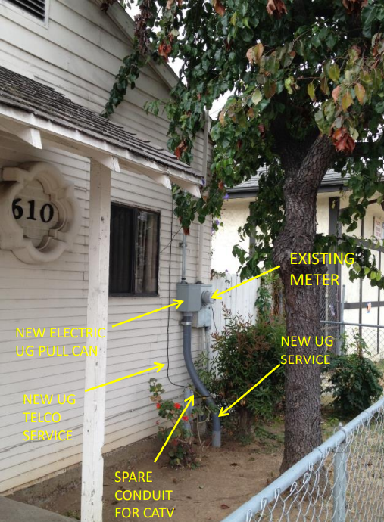
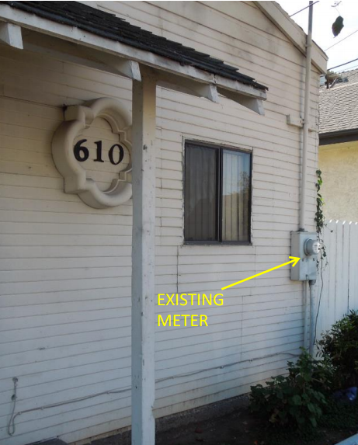
After
Before

Green Book Manual. Accessed February 2022. PG&E Website. https://www.pge.com/en_US/large-business/services/building-and-renovation/greenbook-manual-online/greenbook-manual-online.page
Authors’ Note: The allowances presented here and referenced throughout this document are in scope of the Study. Please note that the allowances are subject to change.
Green Book Manual. Accessed February 2022. PG&E Website. https://www.pge.com/en_US/large-business/services/building-and-renovation/greenbook-manual-online/greenbook-manual-online.page
Span.io Website. Accessed February 2022. https://www.span.io/
Redwood Energy Website. “Watt Diet Calculator.” Accessed February 2022. https://redwoodenergy.net/watt-diet-calculator/
SEIA Website. Accessed February 2022. https://www.seia.org/research-resources/solar-photovoltaic-technology
SEIA Website. Accessed February 2022. https://www.seia.org/research-resources/solar-photovoltaic-technology
PVPMC Website “Inverter Saturation or ‘Clipping’”. Accessed February 2022. https://pvpmc.sandia.gov/modeling-steps/dc-to-ac-conversion/inverter-saturation/
CleanTechnica Website. Accessed February 2022 “120 Volt Heat Pump Water Heaters Hit The Market & Make Gas Replacements Even Easier.” https://cleantechnica.com/2021/11/29/120-volt-heat-pump-water-heaters-hit-the-market-make-gas-replacements-even-easier/
Nyle Technologies ”E8 Product” Accessed February 2022. https://www.nyle.com/water-heating-systems/units/e8/
Redwood Energy Website. “Watt Diet Calculator.” Accessed February 2022. https://redwoodenergy.net/watt-diet-calculator/
EnergyCodeAce Website. Accessed January 2022. https://energycodeace.com/site/custom/public/reference-ace-2019/index.html#!Documents/section11010mandatoryrequirementsforsolarreadybuildings.htm
Authors’ note: This may indicate an error in the respondents’ data entry: it is very possible that they paid $16,000 to their solar contractor or electrician, and only $1002 to the utility. Study administrators were unable to reach the homeowner at their provided phone.
DOE Website. ”Confronting the Duck Curve.” Accessed February 2022. https://www.energy.gov/eere/articles/confronting-duck-curve-how-address-over-generation-solar-energy
PG&E Website. ”PG&E Rule 15”. Accessed February 2022 https://www.pge.com/tariffs/assets/pdf/tariffbook/ELEC_RULES_15.pdf
SDG&E Website. ”SDG&E Rule 15“ Accessed February 2022 https://www.sdge.com/sites/default/files/elec_elec-rules_erule15.pdf
PG&E Website. ”PG&E Rule 16”. Accessed February 2022: https://www.pge.com/tariffs/assets/pdf/tariffbook/ELEC_RULES_16.pdf
SDG&E Website. ”SDG&E Rule 16“ Accessed February 2022: https://www.sdge.com/sites/default/files/elec_elec-rules_erule16.pdf
Richter, H. P., Hartwell, F. P., & Schwan, W. C. (1962). Wiring simplified: Based on the ... National Electrical Code. Minneapolis, MN: Park Pub. https://www.worldcat.org/title/wiring-simplified/oclc/5636171
Richter, H. P., Schwan, W. C. (1947). Wiring simplified: Based on the ... National Electrical Code. Minneapolis, MN: Park Pub.
National Electrical Code, 1959. (1959). United States: National Fire Protection Association. https://www.google.com/books/edition/National_Electrical_Code_1959/KxgBngEACAAJ?hl=en
National Fire Protection Association Advance Reports (1962) https://www.nfpa.org/Assets/files/AboutTheCodes/70/NEC-Advanced%20Repotrt-1962.pdf
HomeAdvisor.com “Electrical Panel Upgrades“ (Accessed December 2021) https://www.homeadvisor.com/cost/electrical/upgrade-an-electrical-panel/
HomeGuide Website. “Costs to Replace and Electrical Panel“ (Accessed December 2021) https://homeguide.com/costs/cost-to-replace-electrical-panel
Angi.com (Formerly Angie‘s List) “Cost to Upgrade to 200-Amp Service (Accessed October 2021) https://www.angi.com/articles/ask-angie-what-does-it-cost-upgrade-200-amps.htm
Fixr.com Cost to Upgrade and Electrical Panel ( Accessed December 2021) https://www.fixr.com/costs/install-electrical-circuit-panel-upgrade
Penna Electric Website. ( Accessed December 2021) ”Why An Electrical Panel Upgrade Is Costly & 3 Reasons It’s Worth It” https://pennaelectric.com/electrician-blog/why-an-electrical-panel-upgrade-is-costly-3-reasons-its-worth-it/
HomeServe.com (Blog). (Accessed December 2021) Post: ”How Much Does It Cost to Replace an Electrical Panel?” https://www.homeserve.com/en-us/blog/cost-guide/replace-electrical-panel/
RemodelingCalculator.com (Accessed February 2022 ) “2022 Cost To Replace An Electrical Panel” https://www.remodelingcalculator.org/cost-upgrade-electrical-panel/
CostHelper Website. ( Accessed December 2021) https://home.costhelper.com/electrical-upgrading-electrical-service.html
TRC (2018) ”City of Palo Alto 2019 Title 24 Energy Reach Code Cost Effectiveness Analysis“ https://www.cityofpaloalto.org/files/assets/public/development-services/green-building-files/2019-palo-alto-reach-code-cost-effectiveness-20180914.pdf
LBNL (2018) ”Electrification of buildings and industry in the United States“ https://ipu.msu.edu/wp-content/uploads/2018/04/LBNL-Electrification-of-Buildings-2018.pdf
Electrify Marin (2021) ”Local Government Programs and Policies for Existing Building Decarbonization“ https://www.marincounty.org/-/media/files/departments/cd/planning/sustainability/electrify-marin/531-lessons-learned-report.pdf?la=en

