January 18, 2019

Attention:
Energy Division
California Public Utilities Commission

SUBJECT: Comments on the January 11th workshop on the 2020 Energy Efficiency Potential and Goals associated Work Plan.

Southern California Edison Company (SCE) appreciates the opportunity to provide comments on the California Public Utilities Commission’s (CPUC) January 11, 2019 workshop on the 2020 Energy Efficiency Potential and Goals. The Energy Division (ED) requested comment to be supplied by January 18th 2019.

- SCE requests that ED provide comment feedback within a reasonable time period.

As the 2019 EE Potential and Goals Update study is scheduled to be completed in May 2019, SCE understands the need to expeditiously complete each work task. In previous years, Energy Division (ED) stakeholder responses to comments were received in the final report after all modeling decisions and professional judgments have been finalized. In order to maximize the usefulness of requested comments, SCE requests that ED respond to stakeholder comments within a reasonable time period leaving time to seek clarification.

- SCE request information on allocation of Program Administrative and Marketing Costs.

In 2011 Administrative costs were evenly spread across all measures energy savings. Cost effective EE Potential was then calculated for SCE’s total service territory, and as long as the disaggregated sum of the Administrative costs equaled total Administrative costs, the methodology was judged to be reasonable.
The environment in which current EE programs operate has changed since 2011, with the need to disaggregate EE Potential to the Building Climate zone, and the calculation of measure level/measure group levelized costs of energy. Given these changes, it is reasonable to expect the EE Potential and Goal methodology used to calculate EE program goals to change as well. Current program administration practices allocate Administrative and Marketing cost differently depending on the program makes updating past assumptions necessary. SCE requests that ED provide updated methodological detail on how Administrative and Marketing costs will be allocated in the 2019 EE Potential and Goals update study. SCE stands ready to aid in expeditiously providing the program data necessary to update allocation methodologies.

- SCE recommends additional changes to Potential and Goals Cost-effectiveness screens.

Approval of the Energy Efficiency (EE) Business Plans in D.18-05-041 placed cost-effectiveness requirements on the EE portfolios, moving the forecasted portfolio Total Resource Cost (TRC) from a 1.0 to a 1.25 in efforts to ensure ex-post results would yield a cost-effective EE portfolio. The EE Potential and Goals study, on the other hand, uses cost effectiveness filters to ensure that the EE Potential and Goals study mimics the EE programs’ ability to construct a cost-effective portfolio that meets or exceeds EE program goals. SCE appreciates the efforts of ED to align with these requirements by moving the historical TRC screen from a threshold of 0.85 to 1.0, however, SCE is concerned that the study scope does not specifically include updating the emerging technology TRC screen. To better align the market achievable potential for emerging technologies, SCE recommends that the current 0.5 threshold be updated to similarly reflect a 1.0 TRC screen.

- SCE recommends alignment of EE load shapes that reflect load shapes used by EE Programs.

Consistent with ED EE program requirements, SCE recommends sole use of DEER load shapes to define EE program goals. SCE plans for EE program goals that specifically reflect the programs’ ability to capture savings. To accomplish this, SCE requests that all model inputs reflect the same inputs that are applied into the EE portfolio planning efforts.

- SCE recommends calibrating locational savings potential at the building climate zone level.

SCE supports the notion of disaggregating EE potential to the building climate zones. To assure disaggregation accuracy, the model should be calibrated at the climate zone level. Without calibrating the model at the climate zones, ED risks suppling a climate zone EE savings values that lack data to support their accuracy.

- SCE recommendations for disaggregating potential across Renewable Energy Networks (RENs) and Community Choice Aggregators (CCAs) to ensure equity and reliable energy savings aligned with the ability to capture savings.

SCE recognizes the complexity of addressing disaggregation of potential for the RENs and CCAs. Currently, CCA and REN offerings are available in overlapping service territories with SCE. The primary focus for this task should be on the avoidance of double counting, recognition of past performance, and ensuring reliable and accurate saving estimates.
Historically, REN offerings in SCE’s territory have been largely supplemental activities to the existing SCE portfolio and are included in SCE’s goal performance, including their resource programs. With REN’s territory overlapping and eventually rolling up to SCE’s portfolio, maintaining the REN’s potential as a subset of SCE’s is the most reasonable approach in the near term. Additionally, RENs are still considered a Pilot pending CPUC decision, thus subsuming REN potential within utility potential is appropriate.
CCAs that currently offer EE programs have focused their efforts on specific segments of customers. Currently, CCA savings are included in SCE’s goal achievement, and the savings are reported directly to the CPUC. As CCA potential is explored, SCE suggests the study’s focus should be on the current offerings of the CCA by sector, and calibrated to their past performance. If the study’s focus includes efforts to identify potential beyond current CCA offerings, SCE requests further discussion to ensure that goals, savings and the ability to capture savings are aligned.

- SCE recommends accounting for uncertainty in timing, cost and performance of on-going solicitations for Third Party and Statewide administration and their impact on the overall EE Portfolio.

The Investor Owned Utilities (IOUs) are currently undergoing solicitations for various portions of their EE portfolios, with anticipated start and ramp up in 2020. While technical potential in the market place may not be impacted by the administration of programs, but economic and achievable potential will be impacted in the short term. In the transition to third party programs, it is reasonable to assume that the ramp up of third-party programs will entail delays in capturing anticipated EE savings. This possible delay should be captured within the modeling methodology. SCE believes that this concern may be reflected in several ways ranging from impacting a customer's willingness to adopt the highest efficiency measures, or accounting for the time needed for third parties to build awareness of their new offerings.

- SCE recommends that changes to low income market potential ensure alignment with the Low-income portfolio ability to capture savings.

SCE is concerned that the proposed new methodology for assessing EE potential in the low-income sector may be misaligned with the Energy Savings Assistance (ESA) program’s ability to capture low income savings. Historically, the approach was simpler and better aligned with how the portfolio captured savings by aligning estimates of low-income service accounts and estimated savings per ESA treatment of each service account. Although few details of the changes to ESA methodology were provided, the proposed methodology seems to deviate significantly from past ESA savings estimates. SCE recognizes that there could be many ways to estimate ESA savings, and SCE is agnostic to the methodology deployed as long as the results align with the ESA program’s ability to capture low income savings.

- SCE recommends updating savings assumptions to account for the most recent publicly available data.

The following table includes suggested sources for savings assumptions and their rationale.

Topic | Updated Savings info | Rationale
- SCE recommends calibrating savings to all of 2017’s program data. | 2017 Quarter 1-4 from the annual report are available on CEDARS as well as Q1-3 of 2018. | EE Stats website has been displaced by the CPUC’s CEDARS website that hosts all data after Q3 of 2017, including final 2017 data and preliminary 2018 Q1-Q3 data, the measure level savings are available here: https://cedars.sound-data.com/reports/record-level/
- New Residential and Commercial measures list. | SCE no longer offers a Tier 2 power strips program. | SCE’s Low-income sector offers a tier 1 powerstrip but the tier 2 power strip is not offered in the EE portfolio due to cost-effectiveness considerations.
- New Residential and Commercial measures list. | SCE recommends classifying the new measures such as Commercial energy management systems and Residential LED with advanced network lighting control system, and universal audit tools in line with CPUC program rules. | SCE recommends that Navigant and the CPUC decide on the applicability to each new measure of the Expected Useful Life (EUL) requirements placed on Behavioral, Retro-commissioning and operational measures. For example, a Commercial Energy Management’s savings would fall under BROs EUL guidance defined in E-4818, limiting the EUL to 2/3 years pending on the classification. If the P&G study assumed the measure had an EUL greater than the 2/3 years it would lead to misalignment with the program’s ability to capture cost-effective savings.  Please see email attachment at the end of document for latest status on the universal audit tool.
- New Residential and Commercial measures list. | Measures previously identified in the 2016 goals created as a requirement of SB350’s unconstrained potential should be revisited. | SCE believes a few measures identified in the last potential study were in line with the Commission’s direction to identify savings “unconstrained” by historical programs but need to be updated. With two years of data, SCE believes that calibration of the savings potential for these measures should be a highlighted effort in the 2020 study. For Zero Net Energy specifically, SCE believes that DERs will play a larger role in meeting the ZNE targets. Furthermore, EE programs, cannot claim savings above meter spin, significantly reducing potential. Measures that should be reviewed include but are not limited to the following:  - Res ZNE  - Com ZNE  - Res Code 2019
- Generic Custom process | Since the current custom project methodology starts with national EE recommendation data by NAICS code, SCE requests the national data be filtered to represent CA specific EE Potential. | SCE’s database of core calculated programs should be used to both identify custom measure packages and claimed savings. SCE strongly suggests the use of most current custom data available (Q4 2017 – Q3 2018), and is prepared to supply said data upon CPUC data request.
- Streetlights | SCE has received guidance from the commission on its portfolio of streetlight projects that should be reflected in the 2020 potential study. | SCE has been grandfathered energy savings from streetlights that are currently in the pipeline and approved through 2020 at savings values approved in the most recent Workpaper revision. In short, the EE potential goals should reflect the portfolio’s ability to capture savings as identified in the attached memo and associated Workpaper. SCE will note that the approved Workpaper is under review to investigate a reasonable baseline.

- The 2019 EE Potential and Goals Study should use current custom program savings to estimate EE savings.

It is SCE’s understanding that Navigant intends to continue to use national data sources (e.g., IAC) and the CPUC’s EEStats as the main data sources to calculate Industrial and Agricultural EE Potential. SCE has concerns about the sole use of said data to estimate EE savings from custom programs.
California’s industrial customers are unique compared national industrial customers as it is very expensive to conduct business in California, and thus industrial customers based in California are likely to be more efficient. As shown in the graphic below, energy sales for the industrial sectors have steadily declined.
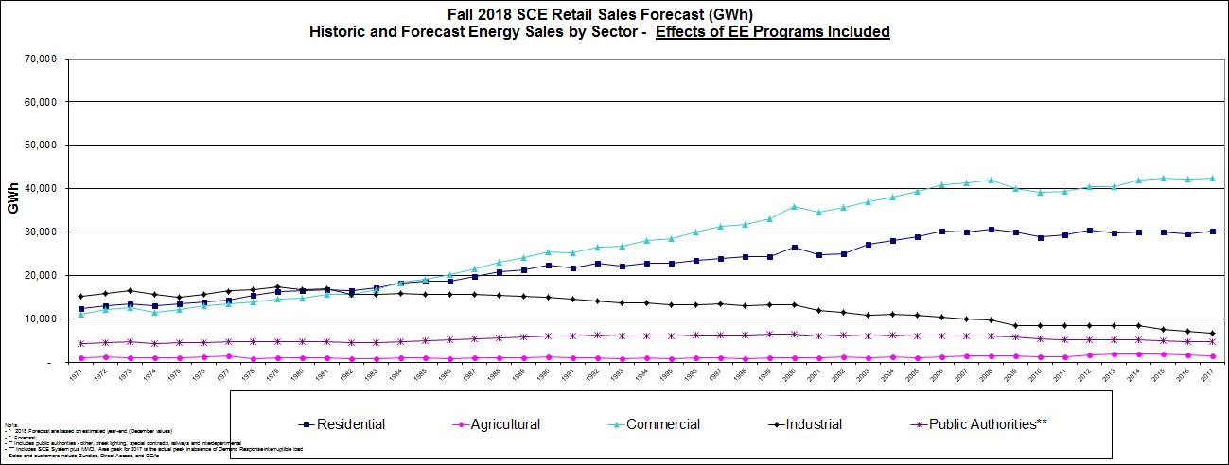
SCE recommends using recent 2018 industrial program to reduce forecast uncertainty. Custom programs can take a long time to come to fruition and these older projects should not be used to estimate future saving as they do not reflect changes program design and Industry Standard Practice designations. Lastly, recent industrial custom program savings can be used to help Navigant design cost effective projects, in lieu of professional judgement, using real world examples of custom projects.

- SCE recommends alternative scenarios to previous studies to help inform the Commission.

SCE recommends including the following scenarios in the 2020 Potential and Goals, which can help inform the IRP deliverables described in Deliverable 14 of the Navigant Workplan.
- Utilize a TRC 1.25 screen for the P&G study with latest Avoided Cost which include the Straight-line Greenhouse Gas (GHG) price recommended in Table 6 of IRP D.17-08-022 and approved in IDER.
- TRC with latest Avoided Cost including the IRP GHG planning price identified in Table 5 of IRP D.17-08-022.
- TRC with latest Avoided Cost which include the Straight-line Greenhouse Gas price recommended in Table 6 of IRP D.17-08-022 and approved in IDER.
- PAC test with latest Avoided Cost including the Straight-line Greenhouse Gas price identified in Table 5 of IRP D.17-08-022.
SCE believes that by including the scenarios above, the CPUC will have access to a range of scenarios of potential to help inform the impacts of various inputs into the potential such as a higher TRC screen, alternative GHG forecasting prices, and different cost-effectiveness screens. Also, EE investigated integration with IRP, the levelized portfolio cost should be made available for these scenarios to assess the impacts of optimizing EE in IRP.

- SCE recommends different specific views of the EE potential.

SCE recommends that the Commission enable the output of the model and associated results viewer to have the following capabilities:
- Toggle between Gross and Net savings for the EE Potential.
- Include Low income and BROs into sector views as appropriate or include as a separate end use.
- Display Portfolio and measure level TRC outputs of the model.
- Display Portfolio EUL over time.

- SCE recommends using the Commission-adopted definition of Disadvantaged Communities (DACs) from Decision 18-05-041 to define the DAC boundaries in each IOU’s service territory.

SCE appreciates the newly included scope to disaggregate the portion of each IOU’s potential that falls under DACs. The CalEnviroScreen tool utilizes a number of indicators to develop a composite “score,” which ranks a given census tract’s overall burden across the variety of indicators relative to all other census tracts’ scores. The EE Business Plan Decision 18-05-041 adopts the CalEPA definition which defines disadvantaged communities as those census tracts scoring in the top 25 percent of census tracts statewide on the set of 20 different indicators in CalEnviroScreen. SCE recommends the top 25 percent scoring census tracts be used to identify each IOU’s potential in DACs.

- CONCLUSION:

In conclusion, SCE appreciates the California Public Utilities Commission’s consideration of these responses and looks forward to continuing collaboration. Please do not hesitate to contact us at your convenience.
Phillip Toth
626-302-6255
Phillip.toth@sce.com

Ryan Bullard
62-302-2899
Ryan.bullard@sce.com

- 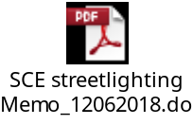
- 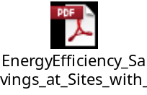
- 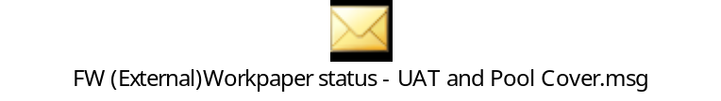

Analysis to Update Energy Efficiency Potential, Goals and Targets for 2013 and Beyond, May 8, 20102 , page 72
3CREN offers program across SCE, SCG and PG&E territory.
CCA savings are not a part of SCE’s earnings.
Measure name is from the slide 13 at the 1/11/19 workshop for the Residential and Commercial Sectors available here: https://pda.energydataweb.com/api/downloads/2122/Group%20E%20Deliverable%2011%20Overview%20-%20January%2011%202019.pdf
Please see attachment at the end of this document for ED Reference.
Please see attachment at the end of this letter for more specifics.
Please see link to CEDARs data in the section IX.3
See website of the California Environmental Protection Agency, Office of Environmental Health Hazard Assessment, CalEnviroScreen Scoring & Modeling: https://oehha.ca.gov/calenviroscreen/scoring-model

